IMITATION IN FDI-BASED ENTRY: THE CASE OF EMERGING MARKET FIRMS ENTERING INTERNATIONAL MARKETS
K.V. Mukundhan (Doctoral Candidate) and Dr. M.K. Nandakumar (Associate Professor) Indian Institute of Management Kozhikode

K.V. Mukundhan*
Doctoral Candidate in Strategic Management
Indian Institute of Management Kozhikode,
IIMK Campus P.O.,
Kunnamangalam,
Kozhikode 673 570, Kerala,
India
Email: mukund03fpm@iimk.ac.in
Phone: +91 - 956 -783 - 0944

M.K. Nandakumar
Chairman - Strategic Management Area,
Chairman – International Exchange Programme,
Indian Institute of Management Kozhikode,
IIMK Campus P.O.,
Kunnamangalam,
Kozhikode 673570, Kerala,
India
Email: nandakumarmk@iimk.ac.in
Phone: +91 – 495 – 2809256

Abstract
The study of inter-organizational imitation has been an important strand of literature on institutional theory. This paper explores the phenomenon of inter-organizational imitation in the context of market entry and FDI location choices of Emerging Market Firms (EMFs). Drawing upon the experience of Indian multinational enterprises, we explain how imitation processes play out depending upon a firm’s organizational form, its multinational experience and the level of economic development in target host countries. In particular, we are interested in understanding the influence of a firm’s reference groups on its choice of market entry modes and FDI locations. Preliminary analysis conducted on a sample of 1629 entries of Indian Multinationals indicate that entry mode strategies are influenced by mimetic pressures operating at the industry and business group level. We conclude this paper by hypothesizing the performance effects of imitation and laying down directions for future research.
Keywords: Isomorphism, Imitation, Entry Modes, FDI Locations, Emerging Market Firms

Introduction
The selection of market entry/establishment mode represents one of the major strategic decisions for an internationalizing firm. Foreign Direct Investment (FDI)-based market entry modes like Cooperative Joint Ventures, Equity Joint Ventures and Wholly Owned Subsidiaries involve ownership of property, assets, projects and businesses in host countries. The choice of entry mode becomes particularly important for developing country firms entering international markets (Pehrsson, 2008). Though a majority of this outward FDI occurs in waves, early research on market entry modes had not looked at the phenomenon from an aggregate perspective (Agarwal & Ramaswami, 1992; Chen & Hu, 2002; Hennart, 1991). When aggregate approaches to studying entry modes were employed, they were conducted on firms across industry boundaries, thereby ignoring broader social and cultural factors at work. Even today, a majority of research on market entry modes comes from the disciplines of finance and managerial economics that emphasize the concepts of economic efficiency and managerial agency (Buckley & Casson, 2003; Teece, 1981; Hennart, 2000). However, recent evidence indicates that market failure and the pursuit of efficiency maximization do not provide a full account of why firms are motivated to pursue certain entry mode choices more than the others (Lu, 2002). In addition, with costs imposed by tariffs, logistics, regulations and other non-tariff barriers declining worldwide, the importance given to transaction costs as determinants of entry mode choice has come under criticism (Duffy, 1996). Alternative theoretical perspectives like organizational learning, social networks etc. have not been sufficient to account for the observed phenomena of EMF internationalization. Most importantly, all the above mentioned approaches fail to account for the role played by institutional practices and structures in restricting a firm’s entry choices (Lu, 2002). Firm decisions and behaviours are nested within their historical and cultural contexts. When undertaking overseas investment decisions, firms face a multitude of uncertainties and are influenced by numerous, and often, conflicting informational cues. As social actors in an institutional environment, firms do not have complete information about economic efficiency and effectiveness of their strategies ex-ante. In such cases, decision makers in firms tend to reduce uncertainty by looking for cues from their social environment and interactions with other firms to gather information about potential opportunities, constraints and legitimacy of their actions. Hence, a firm’s internationalization decisions should be driven by the need to pursue institutional legitimacy in addition to merely achieving cost efficiency.
Since outward FDI involves higher resource commitments and a higher level of risk exposure to environmental influences, institutional view is a suitable theoretical lens to study this phenomenon (Johanson & Vahlne, 1977; DiMaggio & Powell, 1983). This study, therefore, attempts to complement existing theoretical perspectives by proposing an alternative explanation to the entry mode strategies of EMFs by drawing upon insights from the institutional theory of organizations. In particular, this study uses the concepts of international risk and inter-organizational imitation to account for the similarity in the internationalization strategies of Emerging Market Firms entering international markets. To this end, we examine the following research questions in this paper: (i) Does the degree of exhibited isomorphic behaviour vary with the level of economic development of the target host country? (ii) Does the degree of isomorphic behaviour vary with the organizational-form of the focal firm? and (iii) What are the performance implications of isomorphism?
Theory and Hypotheses
EMFs are typically under-resourced to compete in less-restrictive environments (Hu, 1995; Lee & Beamish, 1995). Although EMFs had global operations in the late 1980s and early 1990s, it was not until the beginning of the 2000s that they started playing a dominant role at the international level. Owing to this laggard position in the global business scene, EMFs usually lack skills and abilities to manage risks associated with high resource commitments. When they enter developed markets, EMFs are likely to face discrimination by host country customers and governments and experience a lack of credibility within the organization for their internationalization program. In addition, EMFs can suffer from inappropriate organizational learning routines, lack of access to efficient capital markets and global managerial talent. Thus, the national origins of EMFs may engender legitimacy-based and capability-based disadvantages (Ramachandran & Pant, 2010). Even if an EMF has attained the appropriate standards to compete with developed-market firms, executives may be unaware of the EMF’s global potential or may lack sufficient organizational confidence to exploit skills with a suitable mode of entry (Li, Miller & Eden, 2012).

FDI in developed markets, in the presence of global environmental uncertainty, carries high investment risks. A decision maker’s risk perceptions in the presence of these uncertainties are believed to influence a firm’s choice of entry mode into foreign markets (Ahmed, Mohamed, Tan & Johnson, 2002). In cases of high environmental uncertainty, we argue that firms increasingly rely on social interactions with other institutional actors to obtain information that can help them manage the risks (Meyer & Rowan, 1977; Pfeffer, Salancik & Leblebici, 1976). Thus, rational actors in organizations can be expected to homogenize their organizations through a constraining process of isomorphism whereby their behaviours increasingly start to resemble other firms that face the same set of environmental conditions (Hawley, 1986). Ang & Michailova (2008) identify that the normative and cognitive pillar of institutions exerts greater influence when EMFs enter developed markets while the regulatory pillar influences firm entry into other emerging markets. Since mimetic isomorphism is an organization’s response to seek cognitive legitimacy, we can expect firms to adopt strategies legitimated by the institutional environment when entering developed markets. In this case, the focal firm will be motivated to overcome uncertainty by choosing the market entry strategies that have been frequently chosen by other indigenous firms experiencing the same home environmental conditions. On the other hand, EMFs need not tailor their business models to the prevailing institutional environments of less developed countries (Prahalad & Lieberthal, 1998). As a result, they do not face the same amount of uncertainty in gaining institutional legitimacy when entering less-developed economies. Hence, we expect a greater degree of isomorphic behaviour being exhibited by internationalizing firms when entering developed countries.
- H1a. EMFs engaged in outward FDI in developed countries are more likely to imitate the entry mode strategies of other indigenous firms compared to EMFs that engage in outward FDI in less developed countries
- H1b. EMFs engaged in outward FDI in developed countries are more likely to imitate the location choices of other indigenous firms compared to EMFs that engage in outward FDI in less developed countries

In addition to the frequency-based imitation discussed above, similarity in traits among social actors forms another important basis for interorganizational imitation (DiMaggio & Powell, 1983). The literature on international market entry modes has identified bunching of market entry by foreign firms as assumed consequences of interorganizational imitation (Makino & Delios, 2000; Yamawaki, 1998; Yu & Ito, 1988). These studies have examined conformity of practices between firms based on country of origin (Henisz & Delios, 2001; Lu, 2002; Li et al., 2012) and type of entry mode (Dacin, Oliver & Roy, 2007; Li et al., 2012; Stuart, Hoang & Hybels, 1999). A firm’s referent group is a set of organizations which share a similarity in traits with the focal organization. The trait-based similarity is indicated by one of a lower psychic distance, belonging to the same industry or being exposed to the same environmental conditions. Haunschild and Miner (1997) have considered organization size and financial success as some of the distinguishing traits that firms look for in reference groups. In this paper, we paper, we propose affiliation to the same Business Group as a distinguishing trait-based similarity to explain the onset of mimetic behaviour in EMFs. We argue that the prior actions of group associates form a more meaningful reference group for affiliates and thereby influence their strategic behaviour.

In the year 2000, Tata Tea (now Tata Global Beverages), acquired UK based Tetley Tea for $407 million. The motive of this acquisition was to seek strategic assets in the form of a global brand, worldwide marketing network, and packaging technology. The acquisition also helped Tata Tea to instantly combine its production bases and plantations in India and Sri Lanka vertically with the front end of Tetley, giving it access to customers across the world. This acquisition was a watershed moment in the internationalization of Indian enterprises. The nature of this acquisition was unprecedented in terms of the overseas investments made by firms from emerging economies. It was also the first time that an Indian company acquired a major industry champion in the West that was much bigger in size than itself through leveraged buyout. After the successful experience of Tata–Tetley, other firms belonging to the same business group have increasingly employed acquisitions besides greenfield investments for penetrating overseas markets. In particular, acquisitions of companies with regional or global footprints have served as an attractive option for Indian firms seeking to globalize their operations expeditiously. For example, in 2007, Tata Steel purchased a 100% stake in the Anglo-Dutch global steel maker Corus in an all-cash deal, cumulatively valued at $12.04 billion. The deal was the largest Indian takeover of a foreign company and made Tata Steel the fifth-largest steel group in the world. In 2008, Tata Motors acquired two iconic British brands in Jaguar and Land Rover from Ford Motor Company for $2.3 billion. In 2011, Titan Industries acquired Swiss watch brand Favre Leuba for up to 2 million Euro as part of its strategic business plan to expand product portfolio. Similar behaviour has also been identified among firms belonging to other business groups like the Aditya Birla Group, Murugappa Group and the Amalgamation Group. Thus, we see that prior international experience of group associates can have an isomorphic effect on the subsequent entry mode decisions of affiliated firms.

When entering developed markets, decision makers look up to prior entries made by business group associates to offset risks associated with gaining legitimacy. Group associates, with their prior experience, share information, provide technological and operational synergies and thereby become ‘readily available’ models of inference (Pradhan & Singh, 2010). Firms which are not members of business groups can be expected to rely on their own prior international experiences to guide their choice of entry modes. In the absence of such a history, competitors within the same industry and other domestic firms with successful international experiences can form suitable reference groups for imitation.

- H2a. EMFs engaged in outward FDI in developed countries are more likely to imitate the entry mode choices of business group associates compared to EMFs that engage in outward FDI in less developed countries

- H2b. EMFs engaged in outward FDI in developed countries are more likely to imitate the location choices of business group associates compared to EMFs that engage in outward FDI in less developed countries
When EMFs tend to enter developed markets through outward FDI, they are subjected to increased levels of risk. Like Luo and Tung (2007) point out, EMFs can be perceived as having poor governance and accountability, lacking managerial experience and possessing weak technological capabilities. The risk faced by an EMF gets magnified when global stakeholders view them through these stereotypes. Even well-governed EMFs are likely to fall victim to such negative perceptions.
A firm’s level of experience serves as an important source of uncertainty when entering an overseas market. Firms with no prior experience are uncertain about the market as they lack the "formula" developed from past experiences to approach decisions in the new market. In such cases, the firm begins to search outside its boundaries for models of inference (DiMaggio & Powell, 1983; Haunschild & Miner, 1997). Even when firms have prior experience, they may lack the necessary organizational confidence to make subsequent investments. This dilemma particularly gets exacerbated when a firm might be unaware of its potential to exploit skills with a suitable mode of entry. Thus, we propose that the prior experience of a firm counts as an advantage only in cases where the decision makers perceive low risks associated with overseas investments. Since entering developed markets constitutes a high risk proposition for an EMF, we expect to see a differential effect of experience on the EMF’s choice of entry modes and FDI locations when entering developed and less developed economies.
- H3a: EMFs engaged in outward FDI with prior international experience are more likely to imitate entry mode choices of indigenous firms when entering developed countries compared to entering less developed countries

- H3b: EMFs engaged in outward FDI with prior international experience are more likely to imitate FDI location decisions of indigenous firms when entering developed countries compared to entering less developed countries

EMFs entering developed markets face an increased potential for conflict between the requirements of legitimacy from external and internal stakeholders. As a consequence, EMFs face greater challenges in establishing and maintaining legitimacy in developed markets when compared to entering other less-developed markets. EMFs typically seek legitimacy from a variety of external stakeholders who are guided by certain managerial and technical procedures. Since conformance to legitimated structures and actions increases an organization’s probability of survival, we usually associate isomorphism with positive performance outcomes (DiMaggio & Powell, 1983; Meyer & Rowan, 1977). On the other hand, the likelihood of survival is obtained at expense of financial performance as the firm trades off social legitimacy for technical efficiency. Thus, we can see that certain legitimacy-seeking activities, although contributing negatively to organizational performance in the short-run, assure the future support of certain internal or external constituencies should the organization fall into particularly adverse circumstances. Such support becomes extremely important for firm survival.

Conforming to institutionalized structures and practices also impacts certain non-financial aspects of an organization’s performance. Reputation, for example, is a generalized expectation about a firm’s future behaviour or performance based on collective perceptions of past behaviour on performance (Ferguson et al. 2000). It represents the collective knowledge institutional actors possess about the firm in its institutional field (Fombrun, 1996; Ferguson, Deephouse & Ferguson, 2000; Rindova, Williamson, Petkova & Sever, 2005). When EMFs enter developed markets through FDI-based market entry modes, their stakeholders experience a high degree of uncertainty over the potential success of its proposed overseas investments. Firms can reduce stakeholders’ uncertainty about its decisions by developing a reputation, which in turn provides stakeholders with assurance about the firm’s ability to create value. Firms build reputation by investing persistently in a variety of relevant signals like resource deployment patterns, levels of financial performance and endorsements from high-status or prominent third parties (Roberts & Dowling 2002; Greenwood, Li, Prakash & Deephouse, 2005). In the choice of international entry, conformance to entry mode choices institutionalized by the EMF’s institutional environment reduces uncertainty for stakeholders and provides visibility to the focal firm’s decisions in terms of their value-creating potential. Since international entry mode involves deploying resources in an overseas project or subsidiary, being isomorphic with institutionally-ratified patterns of resource deployment enhances the EMF’s credibility in the eyes of its legitimating actors and paves the way for positive reputation building.
- Research Question 1a: What are the implications of mimetic isomorphism when an EMF chooses its entry modes similar to its reference group organizations?

- Research Question 1b: What are the implications of mimetic isomorphism when an EMF chooses FDI locations similar to its reference group organizations?

Research Method
Data
The study population was FDI-based entry decisions made by listed Indian firms from 2007 to 2013. The data was obtained by combining the (i) Reserve Bank of India data on Outbound Foreign Direct Investment of Indian companies with (ii) Company-specific information of listed Indian companies obtained from PROWESS database. Since we had to compute the entries made by industry and business group firms in the previous year (t-1) according to our study, we had to leave out the data for the year 2007 from our analysis. Similarly, the data for the year 2013 was left out due to the non-availability of values for the control variables like Regulatory Institutions, GDP (2012) and so on. The final sample contained 1629 firms spread across different industries from 2008 to 2012. For studying research questions 1A and 1B, we rely on published information of companies from company archival records, EBSCO Business searching interface, books, and newspaper/magazine reports to gather background information about the company. We then conduct a structured interview with the chief executives of select organizations to understand the motivations entry mode choices and location decisions of firms. We also probe them on the phenomenon of isomorphism and how choosing institutionally-legitimated behaviour enhances organizational reputation. The template of interview questions is attached in Appendix 1.
Model
The proposed conceptual model is illustrated in Figures 1 and 2 (see appendix). The prior entries made by reference groups in a firm’s home environment are hypothesized to positively influence a similarity in a focal firm’s choice of entry modes and location decisions. Although the relative influence of different reference groups that vary by country of origin have been tested in prior research, existing literature is either situated in the context of EMFs entering developed markets (Li et al., 2012) or focuses on one type of entry mode like equity alliances (Ang & Michailova, 2008). On the other hand, we have formulated comparative hypotheses wherein we study the relative influence of reference groups when EMFs enter developed markets vis-à-vis other emerging markets. In addition, we consider the entire range of FDI-based entry modes and don’t just restrict our study to equity alliances. We expect prior business group associate entries to positively influence the focal firm to choose isomorphic entry modes and FDI locations. We then hypothesize that firms enhance their reputation by imitating the behaviour of reference group firms. Although the model lends itself favourably to employing quantitative methods like logistic regression on pooled data, there is scope to test it using a broader range of methodologies including longitudinal and mixed method studies. The conceptual model described above can be expressed in mathematical terms as follows:
For testing frequency based Imitation:
Y_{ijt} = b₀ + b₁ X_{j,t-1} + b₂ d*X_{j,t-1} + b₃X₂ + b₄ d*X₂ + ∑ b_{k}C_{k} + €
Y_{it} = b₀ + b₁ X_{t-1} + b₂ d*X_{t-1} + b₃ X₂ + b₄ d*X₂ + ∑ b_{k}C_{k} + €
where Y_{ijt} = Entry mode chosen by firm i in country j at time t;
Yit = FDI Location chosen by firm i at time t;
X_{j,t-1} = Proportion of home environment entries using same entry mode to country j at time t-1;
d = Developed/Less Developed Country Dummy,
X_{t-1} = Proportion of similar home environment entries to country j at time t-1;
X₂ = Prior Experience of firm i in market j;
C_{k} = control variables
For testing trait based imitation:
Y_{ijt} = b₀ + b₁ X_{j,t-1} + b₂ m*X_{j,t-1} + b₃ X₂ + b₄ d*X₂ + ∑ b_{k}C_{k} + €
Y_{it} = b₀ + b₁ X_{t-1} + b₂ d*X_{t-1} + b₃ X₂ + b₄ d*X₂ + ∑ b_{k}C_{k} + €
where Y_{ijt} = Entry mode chosen by firm i in country j at time t;
Y_{it} = FDI Location chosen by firm i at time t;
X_{j,t-1} = Proportion of prior business group associate entries using same entry mode to country j at time t-1;
d = Developed/Less Developed Country Dummy,
X_{t-1} = Proportion of prior business group associate entries to country j at time t-1;
X₂ = Prior Experience of firm i in market j;
C_{k} = control variables
Case Study Approach
Research Questions 1A and 1B will be studied by employing qualitative techniques. The exploratory nature of the research question and less explored niches in the established field of study makes the application of qualitative techniques appropriate. Also, as there is a paucity of data points available to study the influence exerted by prior business group associate entries on affiliates, the subject does not lend itself for administering a survey-based study. Thus, we expect to capture the dynamics of this influence using the case study approach and follow the lead of Deng (2009), Klein and Wöcke (2007), Li (2007) and Rui and Yip (2008) in selecting a sample of three firms for our study.
Measures
We propose to test the hypotheses using a combination of quantitative and qualitative research methods. Since our problem incorporates the need to explore as well as explain, it lends itself suitable for the employment of mixed methods (Creswell, 1994). Hypotheses 1A, 1B, 2A, 2B, 3A and 3B will be tested using quantitative methods. For EMF entry in developed markets, we consider the entries in 8 OECD countries US, Japan, Germany, France, the UK, Italy, Canada, and Spain. Selection of these countries is consistent with the UNCTAD definition of developed markets and the practice involved in prior literature.

Dependent Variable
The dependent variable is binary, with a 0 corresponding to whether the focal firm entered the international market through Joint Venture (JV) based entry modes and 1 corresponding to Wholly Owned Subsidiary (WOS) based entry modes.

Independent Variables
The number of prior entries from the firm’s environment is measured by counting the number of JV/WOS entries made by firms from the focal firm’s home industry at time (t-1) with ‘t’ being the year of interest. This choice of time period is consistent with the one chosen by Li et al (2012). Prior proportion of Joint Venture entries is calculated as follows:
Prior Proportion of Joint Venture Entries at time‘t’ = (No. of Joint Venture entries from industry i to country j at time t-1) / (Total no. of JV + WOS entries to industry i and country j at time t-1).
Similarly, the prior proportion of WOS entries is also calculated. To calculate prior proportion of Business Group entries, we calculate the total number of JV (or WOS) entries made by business group associates at time‘t-1’ and divide it by the total number of business group entries (JV + WOS) made by the business group associates in the same year. A firm’s prior international experience is binary coded with ‘0’ representing a lack of international experience in the last ten years and ‘1’ representing the presence of international activity. Corporate motivations are assigned a value ‘0’, ‘1’ and ‘2’ corresponding to Asset-Seeking, Efficiency-Seeking and Market-Seeking Investments respectively.

Control Variables
We control for industry effects by introducing dummy variables to gauge the relatedness of the overseas firm/entity to the focal firm’s industry. If the focal firm and its overseas partner/entity are in the same industry, we code them ‘1’ and a ‘0’ if they belong to different industries. Cultural distance is known to affect a decision maker’s perception of uncertainty. Cultural proximity between home and host countries would indicate that the management possesses the information required to operate in a foreign market. This enhances their understanding of local environment and business practices and reduces costs of information acquisition. Since firms are equipped with information to make decisions under uncertainty, cultural proximity between firms is expected to negatively influence a firm’s tendency to imitate the behaviour of reference group firms. Hence, we control for cultural proximity by using Hosfstede’s (1980) cultural index based on four dimensions. We control for the regulatory institutions in the host country as it has been identified to affect entry mode choices in the prior literature. We operationalize this variable through World Bank development indicators similar to Ang & Michailova (2008). In addition, we also control for the per-capita GDP of the host country in our model.

Tests for Robustness:
Diagnostic tests were run on the dataset to test for (i) Pairwise Correlations, (2) Model Specification Errors, (3) Goodness of Fit Test, and (4) Multicollinearity. The results obtained for each tests are discussed below.
The pairwise correlations between independent and control variables at 95% confidence intervals did not indicate any significant correlations. The results of the correlations have been displayed in Figure 3a. Following a basic logic model, we tested the model for specification errors using the linktest command in STATA. Here, we use the linear predicted value and its squared value to rebuild the model. If the model is properly specified, we should not be able to find any additional predictors that are statistically significant except by chance. The linear predicted value _hat should be a statistically significant predictor, since it is the predicted value from the model. This will be the case unless the model is completely misspecified. On the other hand, if our model is properly specified, the linear predicted value squared _hatsq shouldn't have much predictive power except by chance. For our logit model, _hat turned out to be statistically significant while _hatsq was not, thereby lending credence to the way our model has been specified.
We used the Hosmer and Lemeshow’s test to estimate the goodness of fit of our logit model. The idea behind this test is that the predicted frequency and observed frequency should match closely, and that the more closely they match, the better the fit. The goodness-of-fit statistic is computed as the Pearson chi-square from the contingency table of observed frequencies and expected frequencies. A good fit as measured by Hosmer and Lemeshow's test will yield a large p-value. With the p-value of .74 (Prob > Chi2) for our model, we can say that Hosmer and Lemeshow's goodness-of-fit test indicates that our model fits the data reasonably well. Multicollinearity occurs when two or more independent variables in the model are approximately determined by a linear combination of other independent variables in the model. We test for multicollinearity in our data by using the user-written collin function in STATA that is widely used to perform collinearity diagnostics. For our model, the Variance Inflation Factors (VIFs) of all predictor and control variables were less than 3, indicating the absence of collinearity. Alternatively, the VIFs of the dummy predictor variables show a high negative value because the pooled cross-section time series nature of the data has not been taken into account while running diagnostics. Also, the dummy variables on motivation are highly correlated with each other, as can be observed in the pwcorr tables itself and hence the anomaly in their VIFs. The diagnostic results are presented in Figure 3b.

(Partial) Results:
The overall model including all explanatory variables was tested by running Population-Averaged (pooled) models with unstructured correlations in STATA. The explanatory variables, barring industry relatedness, turned out to be significant at the 95% significance level. The results have been displayed in Figure 4.
Hypothesis 1a: Prior Industry Entries made at time t-1 were found to positively and significantly influence the focal firm’s choice of entry mode at time‘t’. This indicates the existence of frequency-based imitation in the market entry choices of Indian firms. In addition, we notice from Figure 5a that the log likelihood if the interaction term (inter1) is positive and the significant, indicating that the likelihood of imitation is greater as Indian firms enter developed countries through FDI-based entry modes.

Hypothesis 2a: Prior Business Group entries at time t-1 were found to positively influence the focal firm’s choice of entry mode at time‘t’. This indicates that business group associates of the focal firm form a reference group and firms closely watch the internationalization behaviour of their business group associates. This is also visible in the positive log likelihood value for ppbge in Figure 5b. However, the interaction term inter2 is not significant indicating that trait based imitation, while present in the companies of interest, does not significantly vary between EMF entries into developed and less developed countries.

At the time of writing this paper, the other hypotheses are yet to be tested and hence their results have not been included.

Expected Conclusions and Future Research
In this study, we propose to go beyond conventional theoretical perspectives to project organizational isomorphism as an alternative theory to explain the choice of EMF entry modes and location decisions. In the context of firms from emerging economies, we have tried to explain the relative degree of isomorphic behaviour exhibited by EMFs as they enter developed markets and other emerging markets. In addition, we have projected business group associates as a potential reference group and a readily available model of inference for firms seeking to invest abroad via the FDI route. We concluded by hypothesizing how isomorphism helps the focal organization to improve its corporate reputation.

However, despite the novelty of its propositions, this study is not without its limitations. In this study, we have assumed that the focal firm has sufficient home country firms in their reference group which can influence their behaviour. Similarly, in the context of projecting business group associates as potential reference groups, we assumed that a firm stands to gain from the prior actions of its business group associates. If there are very less prior actions available for the focal firm from their reference groups, firms may rely on information from other reference groups in addition to drawing upon their own prior international experiences. Also, since an overwhelming majority of EMF internationalization occurs through the acquisition route, we have considered the imitation effects on the dominant entry mode, i.e. Joint Ventures and Wholly-Owned subsidiaries. Future research must examine alternative entry modes like International Joint Ventures to see the effect the type of entry mode have on the extent of isomorphic behaviour exhibited by EMFs.

Further, the role of corporate investment motivations and prior international experience in influencing likelihood of imitation needs empirical scrutiny. Future research should also examine whether the role of corporate motivations in the choice of entry modes varies for developed and less developed countries. Since organizations resort to isomorphic behaviour in response to environmental uncertainties, future research should study the effect of national cultural variables like uncertainty avoidance and power distance on the imitation strategies of EMFs. In this study, we have used anecdotal evidence from Indian firms to theorize the behaviour of EMFs. The geographic focus of the study needs to be widened to extend the theory to other emerging markets. Finally, scholarly attention is also required in examining the effects of isomorphism in the context of EMFs entering other developing economies.

The findings of this study, when completed, will have significant implications for management theory and practice. The study proposes to advance theory on organizational imitation in the context of international market entry modes. To our knowledge, this study is one of the first to study isomorphism in the context of Emerging Market Firms entering developed markets. By considering the legitimating pressures enforced by an MNE’s internal and external environment, we address the issue of oversimplification where more than one base of MNE decision making (entry choices and location choices) is considered simultaneously. In addition, this paper studies uncertainty at the decision making level and provides a better understanding of the business environment in which firms and decision makers operate. In the process, this study responds to the call for better theoretical integration to study emerging phenomena in international business (Kostava, Roth and Dacin 2008). This study informs managers about whom to imitate, why to imitate and who (among their competitors) are likely to imitate.

References:
Agarwal, S., & Ramaswami, S. N. 1992. Choice of foreign market entry mode: Impact of ownership, location and internalization factors. Journal of International Business Studies, 23(1): 1-27.

Ahmed, Z.U., Mohamad, O., Tan, B., & Johnson, J. P. 2002. International Risk Perceptions and Mode of Entry: A case study of Malaysian Multinational Firms. Journal of Business Research, 55: 805-813.

Ang, H.S., & Michailova, S. 2008. Institutional explanations of cross-border alliance modes: The case of emerging economies firms. Management International Review, 48(5): 551-576.

Buckley, P. J., & Casson, M. 2003. The future of the multinational enterprise in retrospect and in prospect. Journal of International Business Studies, 34 (2): 219-222.

Chen, H., & Hu, M. Y. 2002. An analysis of determinants of entry mode and its impact on performance. International Business Review, 11(2): 193-210.
Creswell, J. W. 1994. Research design. Thousand Oaks, California: Sage publications.
Dacin, M. T., Oliver, C., & Roy, J. P. 2007. The legitimacy of strategic alliances: An institutional perspective. Strategic Management Journal, 28(2): 169–187.
Deng, P. 2009. Why do Chinese firms tend to acquire strategic assets in international expansion? Journal of World Business, 44(1): 74-84.

DiMaggio P., & Powell, W. 1983. The iron cage revisited: Institutional isomorphism and collective rationality in organizational fields. American Sociological Review; 48(2): 147–160.
Duffy R. 1996. Moving into the global market place: Stages of Development. In L. Robert & S. Suren (Eds.), Global Finance 2000: A Handbook of Strategy and Organization from the Conference Board. New York: The Conference Board.

Ferguson, T. D., Deephouse, D. L., & Ferguson, W. L. 2000. Do strategic groups differ in reputation? Strategic Management Journal, 21 (12): 1195-1214.

Fombrun, C. J. 1996. Reputation: Realizing value from the corporate image. Boston: Harvard Business Press.

Greenwood, R., Li, S. X., Prakash, R., & Deephouse, D. L. 2005. Reputation, diversification, and organizational explanations of performance in professional service firms. Organization Science, 16 (6): 661-673.

Haunschild, P., & Miner, A. 1997. Modes of interorganizational imitation: The effects of outcome salience and uncertainty. Administrative Science Quarterly, 42(3): 472–500.

Hennart, J. F. 1991. The transaction costs theory of joint ventures: An empirical study of Japanese subsidiaries in the United States. Management Science, 37(4): 483–497.
Hennart, J. F. 2000. Transaction costs theory and the multinational enterprise. In C. Pitelis & R. Sudgen (Eds.), The Nature of the Transnational Firm, vol. 2: 81-116. London: Routledge.

Hawley, A. H. 1986. Human Ecology: A Theoretical Essay. Chicago: University of Chicago Press.
Henisz, W. & Delios, A. 2001. Uncertainty, imitation, and plant location: Japanese multinational corporations, 1990–1996. Administrative Science Quarterly, 46(3): 443–475.

Hofstede, G. 1980. Culture’s Consequences: International Differences in Work-Related Values. California: Sage Publications.

Hu, Y. S. 1995. The international transferability of the firm's advantages. California Management Review, 37(4): 73-88.

Johanson, J. & Vahlne, J. E. 1977. The internationalization process of the firm: A model of knowledge development and increasing foreign market commitments. Journal of International Business Studies, 8(1): 23-32.
Klein, S., & Wöcke, A. 2007. Emerging global contenders: The South African experience. Journal of International Management, 13(3): 319-337.

Kostava, T.; Roth, K. and Dacin, M.T. 2008. Institutional Theory in the Study of Multinational Corporations: A Critique and new Directions. The Academy of Management Review, 33 (4): 994-1006.

Lee, C., & Beamish, P. W. 1995. The characteristics and performance of Korean joint ventures in LDCs. Journal of International Business Studies, 26(3): 637-654.

Li, D., Miller, S. R., & Eden, L. 2012. Entry Mode Decisions by Emerging-Market Firms Investing in Developed Markets. In L. Tihanyi, T. M. Devinney & T. Pedersen (Eds.), Advances in International Management, vol. 25: 207-231. London: Emerald Publishing.

Li, P. P. 2007. Toward an integrated theory of multinational evolution: The evidence of Chinese multinational enterprises as latecomers. Journal of International Management, 13(3): 296-318.

Lu, J. 2002. Intra- and inter-organization imitative behavior: Institutional influences on Japanese firms’ entry mode choice. Journal of International Business Studies, 33(1): 19–37.
Luo, Y., & Tung, R. L. 2007. International expansion of emerging market enterprises: A springboard perspective. Journal of International Business Studies, 38(4): 481–498.

Makino, S., & Delios, A. 2000. Competitive reaction, imitation and bunching in foreign entry decisions. Academy of Management Proceedings, C1-C6.

Meyer, J.W., & Rowan, B. 1977. Institutionalized organizations: Formal structure as myth and ceremony. American Journal of Sociology, 83(2): 340-363.
Pfeffer, J., Salancik, G. R., & Leblebici, H. 1976. The effect of uncertainty on the use of social influence in organizational decision making. Administrative Science Quarterly, 21(2): 227-245.

Pradhan, J. P., & Singh, N. 2010. Group Affiliation and Location of Indian Firms’ Foreign Acquisitions. MPRA Paper 24018, University Library of Munich, Munich, Germany.

Prahalad, C.K., & Lieberthal, K. 1998. The end of corporate imperialism. Harvard Business Review, 76: 68-79.

Ramachandran J, Pant A. 2010. The liabilities of origin: An emerging economy perspective on the costs of doing business abroad. In L. Tihanyi, T. M. Devinney & T. Pedersen (Eds.), Advances in International Management, vol. 23: 231-265. London: Emerald Publishing.

Rindova, V. P., Williamson, I. O., Petkova, A. P., & Sever, J. M. 2005. Being good or being known: An empirical examination of the dimensions, antecedents, and consequences of organizational reputation. Academy of Management Journal, 48(6): 1033-1049.

Roberts, P. W., & Dowling, G. R. 2002. Corporate reputation and sustained superior financial performance. Strategic Management Journal, 23(12): 1077-1093.
Rui, H., & Yip, G. S. 2008. Foreign acquisitions by Chinese firms: A strategic intent perspective. Journal of World Business, 43(2): 213-226.

Stuart, T., Hoang, H., & Hybels, R. 1999. Organizational endorsements and the performance of entrepreneurial ventures. Administrative Science Quarterly, 44(2): 315–349.

Teece, D. 1981. The Multinational Enterprise: Market Failure and Market Power Considerations. Sloan Management Review, 22 (3): 3-17.

Yamawaki, H. 1998. Bunching in foreign direct investment: Evidence on Japanese firms in U.S. manufacturing industries. CIBER working paper No. 98-20, UCLA Anderson school of Management, Los Angeles, CA.

Yu, C. M. J., & Ito, K. 1988. Oligopolistic reaction and foreign direct investment: The case of the U.S. tire and textile industries. Journal of International Business Studies, 19: 449-460.

Figure 1: A Conceptual Model of Mimetic Isomorphism in FDI Market Entry

ENTRY MODES OF INDIGENOUS FIRMS (t-1)
ENTRY MODE OF FOCAL FIRM (t)
REPUTATION
PRIOR INTERNATIONAL
EXPERIENCE
ENTRY MODES OF BUSINESS GROUP ASSOCIATES (t-1)

Figure 2: A Conceptual Model of Mimetic Isomorphism in FDI Location Choices

LOCATION CHOICES OF INDIGENOUS FIRMS (t-1)
LOCATION CHOICE OF FOCAL FIRM (t)
REPUTATION
PRIOR INTERNATIONAL
EXPERIENCE
LOCATION CHOICES OF BUSINESS GROUP ASSOCIATES (t-1)
Figure 3a: Pairwise Correlations
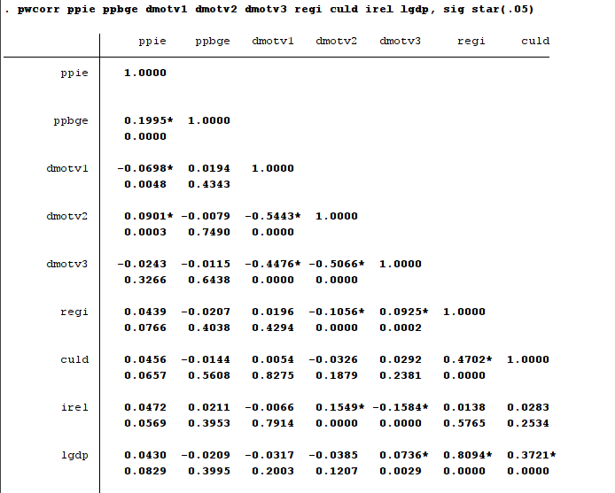
Figure 3b: Collinearity Diagnostics

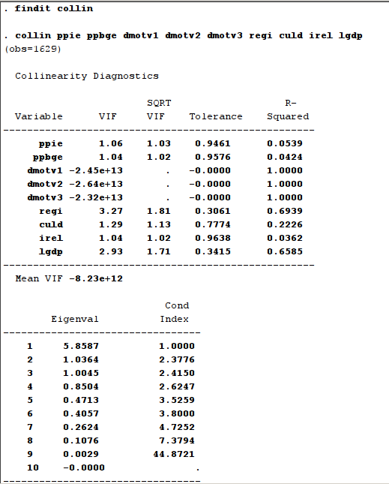
Figure 4: Population-Averaged (Pooled) Effects on Overall Model

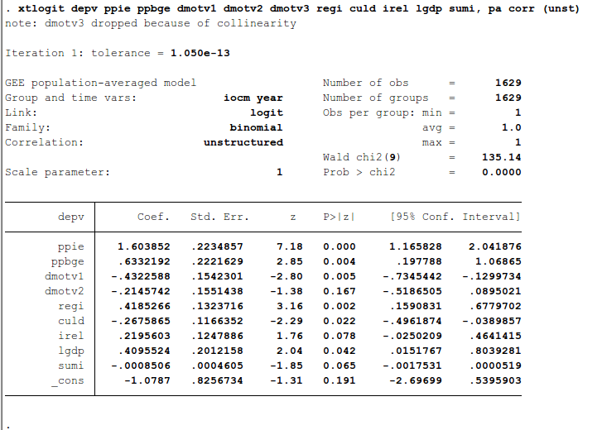

Variable Abbreviations:
depv = dependent variable
dmotv = dummy variables for investment motivations
ppie = Proportion of Prior Entries using same mode from same industry
ppbge – Proportion of Prior Entries using same mode from same business group
irel = Industry Relatedness, estimated at 2 Digit SIC level
culd = Cultural Distance, based on Hofstede’s 4 dimensions
regi = Regulatory Institutions, modelled based on World Bank Development indicators for each country
lgdp = Logarithm of GDP per capita
Figure 5a: Frequency-Based Imitation Effects in Outbound FDI

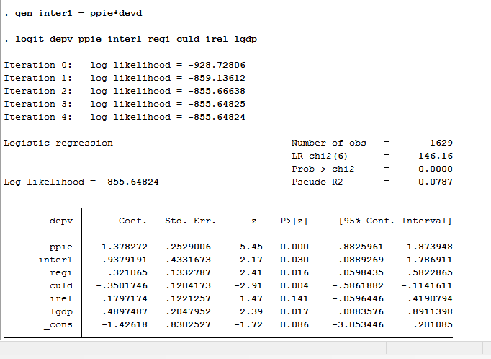

Figure 5b: Trait Based Imitation in Outward FDI

