Multilatinas’s Mergers and Acquisitions: what and where the ocelots are hunting?
Ionara Costa
Marie Curie Fellow
CENTRIM, University of Brighton
I.daCosta@brighton.ac.uk

Paper prepared for The 4th Copenhagen Conference on:
‘Emerging Multinationals’: Outward Investment from Emerging Economies

Draft Version, 20 September 2014

Abstract
This paper looks at multilatinas’ merger and acquisition activities in order to shed light on the internationalization process they have been pursuing. The analysis points to two important features of multilatinas’ international expansion. First, it points to the relatively greater importance of market-seeking motivations behind multilatinas’ cross-border M&As when compared to strategic asset-seeking drivers, contrasting to findings of studies on Chinese and Indian multinationals. Second, the analysis suggests that, though not an outstanding driver, technology-seeking motivation plays a role in multilatinas’ cross-border acquisitions. The findings from the analysis developed in this paper represent an important background for the study on knowledge flows involving the European subsidiaries of multilatinas that has been carried out by the author. The relationship between the motivations of overseas M&A activities and the drivers behind the internationalization process is well established by the international business literature. In this line, the paper points to the relatively importance of multilatinas M&As in high-tech sectors in the European territory. The ocelots seem to be hunting in Europe.

1 Introduction
Ocelot is a small feline, also known as the dwarf leopard, distributed extensively over Mexico, Central and South America. In line with the well-established term Asian Tigers, ocelot is used here as an analogy for Latin American multinationals, the so-called multilatinas: they are smaller than the tigers, but skilled hunters; they are very territorial, and will fight fiercely to defend their domains.
This paper addresses multilatinas’ internationalization process by looking at their merger and acquisition (M&A) activities. The direct aim is to shed light on multilatinas’ internationalization patterns. This paper is a preliminary step of a broader research on flows of knowledge between multilatinas’ European subsidiaries and both their headquarters and host environments. Though M&A activities alone cannot reflect the exchange of knowledge within multilatinas, the paper expects to gain some insights into this direction. The international business research establishes a direct relationship between the motivations to international expansion and how a company chooses to enter into foreign markets (Buckley, Forsan and Munjal, 2009). Scholars have claimed that the search for strategic assets - like knowledge, technology and brands, has been an important motivation behind the international expansion of companies from emerging markets, the emerging multinationals (E-MNCs) (Goldstein, 2007a; Carvalho, Costa and Duysters, 2010a). Many studies have suggested that mergers, acquisitions and strategic alliances are E-MNCs’ preferred mode to enter into foreign markets, particularly the advanced ones, when the main motivation is strategic asset seeking (Duysters, Cloodt, Schoenmakersand and Jacob , 2008; Balasubramanyam, 2010; Pradhan, 2010). If such a strategy is successful, that is, whether the E-MNCs meet their alleged goal of knowledge sourcing by acquiring or joining forces with foreign companies outside their home countries, one can assume it will imply exchange of knowledge across borders within the E-MNCs. Therefore, even if indirectly, the patterns of E-MNCs’ M&A activities can give some hints on the potential knowledge flows within those companies.
In this paper, multilatinas refer to companies that carry out value adding activities outside their home countries (basically what defines a company as a multinational one), and are headquartered in countries from the American continent that have Latin roots linked to the Spanish, Portuguese and French colonization in the region (Cuervo-Cazurra, 2010). In practical terms, Brazil, Mexico, Chile and Argentina are the home for the bulk of the multilatinas identified in several specialized rankings (Boston Consulting Group, América Economía and UNCTAD), with Colombia, Peru, Venezuela, Ecuador and Guatemala headquartering a few of them. The analysis presented in this paper focuses on the first four countries. Companies from these four countries account for the vast majority of multilatinas. Brazil and Mexico, for example, account for 62 percent of the companies in the Boston Consulting Group’s ranking of multilatinas (BCG, 2009a). Therefore, one can assume that Argentine, Brazilian, Chilean and Mexican multinationals are highly representative of multilatinas.
Since the early 2000s, the presence of companies from emerging economies in the international market through foreign direct investment (FDI), and their shares as acquirers in international merger and acquisition deals have been ever growing. As their internationalization accelerates, E-MNCs are gaining space in the global business arena, so far largely dominated by established multinationals headquartered in the triadic developed economies – United States, Western Europe and Japan.
The phenomenon of the E-MNCs is usually illustrated by figures on flows and stocks of outward FDI from emerging and transition economies. UNCTAD data reveal that the share of FDI flows originating in those economies in the world total grew from around 10 percent in 2000 to 25 percent in 2009 (UNCTAD, 2010). In spite of the good picture provided by FDI statistics, the instances of E-MNCs are even more illustrative of the phenomenon than the volume of FDI. Company names such as Lenovo, Acer, HSBC, Cemex, Embraer, Vale, Tenaris, Suzlon Energy and Tata are becoming increasingly well known worldwide.
The increasing participation of E-MNCs in global M&A deals, particularly as acquirer of companies from developed economies, has been remarkable (AT Kearney, 2008; The Economist, 2008; BCG, 2009b). For instance, Tata Motors, which is part of the Indian conglomerate Tata, acquired the British brands Jaguar and Land Rover in 2008; in 2006, Mittal Steel, also from India, took over the European-based Arcelor, creating the giant Arcelor Mittal; Cemex bought the RMC from the UK and the Rinker from Australia, in 2005 and 2007 respectively; Vale from Brazil took over Inco from Canada in 2006. The high values of many of those deals have also been impressive, and can be considered as an indication of the weight of many E-MNCs in their industries of activities – many E-MNCs have attained global leadership positions. Cemex, Tenaris, Embraer and Vale are outstanding cases on this regard from Latin America. Cemex is one of the three global leaders in the cement industry, competing head-a-head with the French multinational, Lafarge and the Swiss, Holcim (Casanova, Fraser and Hoeber, 2009; Cuervo-Cazurra, 2007; Casanova and Fraser, 2009b). Tenaris, which is part of the Argentine group Techint, is the world leader in the production of seamless steel tubes used in the drilling and extraction of oil and natural gas (Cuervo-Cazurra, 2007). The Brazilian Embraer is the third largest aircraft producer in the world, just after Boeing and Airbus, being the world leader in the construction of regional aircrafts (Cuervo-Cazurra, 2008; The Economist, 2008; BCG, 2009b). The Brazilian Vale is amongst the largest mining companies in the world, being the world leader in iron ore and pellets (BCG, 2009b; Casanova and Hoeber, 2009).
The number of studies on E-MNCs has increased, particularly focused on what drives the emergence of emerging countries’ multinationals, what these companies are looking for while expanding abroad, and what their competitive strengths to become multinationals are. However, despite of its growing relevance this phenomenon has still been under investigated, and a significant amount of both empirical and theoretical research is needed in order to advance our understanding about it. Moreover, multilatinas are rather an under researched group of E-MNCs (Cuervo-Cazurra, 2010). Amongst studies on E-MNCs, an overwhelming number of works deal with East Asian companies, notably from China and India. By way of illustration, a hasty examination of the titles of 241 works on E-MNCs compiled in 2009 indicates that around 42 percent of them deal with Asian E-MNCs, 30 percent alone being about Chinese and Indian multinationals and only 14 percent of the works deal with multilatinas. Therefore, this paper gives a contribution to broaden the understanding of the emerging phenomenon of emerging multinationals, and, most importantly of the even more-under investigated sub-group of E-MNCs, the multilatinas.
The paper is organized as follows. Section 2 presents the main aspects of the theoretical and analytical background of the E-MNCs studies, which represent a reference to the analysis of M&A activities by multilatinas, developed in Sections 4 and 5. Section 3 presents the methodological aspects of this study, such as the data bases used, and the main categories for the analysis. Section 4 analyses the general trends of M&A activities involving Latin American companies, benchmarking with China and India. The aim of this section is to get a better understanding of the M&A activities in the region, and the relative importance of their different orientation – inward, outward and domestic. Section 5 focuses on multilatinas’ outbound M&A activities, with the purpose of getting some insights on the patterns of internationalization strategies pursued by these companies, based on their use of mergers and acquisitions to enter foreign markets. Section 6 discusses the findings and presents the concluding remarks.
2 Theoretical and analytical background - early & emerging multinationals
Emerging multinationals are a relatively new phenomenon, and the research on the topic is still in its infancy Theoretically, the majority of studies on E-MNCs have relied on the approaches and theories developed to analyze the earlier internationalization of companies from developed economies – that can be referred to as early multinationals. The suitability of those mainstream theories to explain the emergency of E-MNCs has been disputed (Goldstein, 2007a; Amighini, Sanfilippo and Rabellotti, 2009). The following paragraphs highlight the main aspects of the extant research on early multinationals used in studies on E-MNCs, as well as their limitations in explaining these emerging global players.
Advantages and multinationalisation
The core of the extant theories of internationalization or foreign direct investment (FDI) refers to the reasons for originally domestic companies to engage in value adding activities abroad and become multinationals. The dominant explanation is that those companies possess certain assets, resources or capabilities, especially technology-related ones that give them monopolistic advantages against local companies in foreign host countries – the so-called ownership (O) or firm-specific advantages (FSA). Based on the internalization and the transaction cost theories, it is claimed that companies facing the need to decide on how to make the most of their FSA or O- advantages would opt for internalizing the exploitation of such assets abroad and engaging in FDI when this strategy would imply less transaction costs and be more efficient than any market mechanisms, such as licensing or exports (Buckley and Casson, 1976; Rugman, 1981; Hennart, 2001; Dunning, 2003; Suh and Wang, 2008). Regarding the decision of where to invest, companies possessing O-advantages would also take into consideration the location advantages (L) or country-specific advantages (CSA) of potential host economies. John Dunning synthesized these reasons in his eclectic paradigm, also known as the OLI approach, in which O stands for ownership, L for localization and I internalization advantages (Dunning, 1981). According to the mainstream of MNC studies, asset-exploiting FDI reflects different drivers and strategies, normally summarized as: market seeking – FDI classical reason; efficiency seeking and natural resource seeking (Goldstein, 2007a; Amighini et al., 2009).
The research on E-MNCs has followed these lines by focusing on the factors driving companies from emerging economies to engage in outward FDI and become multinationals (see for instance Deng, 2004; Aulakh, 2007; Buckley, Clegg, Cross, Liu, Voss and Zheng, 2007). A central issue surrounding the studies on E-MNCs is whether these companies have any ownership advantages, especially technology that can be exploited abroad, and that would represent strong competitive edge over the already well-established early multinationals. This question gains even more emphasis when it comes to explain the entering of E-MNCs into advanced economies. Empirical research on this matter has provided mixed answers. For instance, John Dunning, in answering some critics to the explanatory power of his OLI approach for the case of E-MNCs, contended that some E-MNCs might indeed have some competitive advantages that distinguish them from their competitors and explain their multinationalisation (Dunning, 1981; Dunning, 2006; Amighini et al., 2009).
It has also been suggested that E-MNCs’ advantages – if they possess some – are not as sophisticated as those of the early multinationals, normally related to technological assets, brand names and other intellectual properties, but refer more to production, organizational and management capabilities and skills (Chudnovsky and Lopez, 1999; Amighini et al., 2009). However, some scholars claim that it is indeed the lack – not the possession – of key strategic assets, especially global brands and technology that drives companies from emerging economies to directly investing abroad, particularly in developed economies (Moon and Roehl, 2001; Goldstein, 2007a; Amighini et al., 2009). In this line, companies from emerging economies would be internationalizing with the aim of getting access to strategic assets that can help them to develop ownership advantages at the first place.
This claim encounters parallel in the contributions from the studies on early multinationals associated with the relatively recent resource- and knowledge-based views of the firm. In the global knowledge economy, as the early multinationals face increased competition and innovation becomes crucial, the search for localized sources of strategic knowledge that can help to sustain, enhance and enlarge their competitive strengths become also a motivation for investing abroad, particularly in R&D-related activities. In addition to the three afore mentioned categories, this motivation to directly invest abroad has been referred to as strategic asset-seeking or asset-exploration strategy (Dunning and Narula, 1995; Kuemmerle, 1999). On this matter, some studies point also to limitations of such contributions of studies on early multinationals when it comes to explain the E-MNCs’ motivations for FDI. First, strategic asset seeking may explain E-MNCs’ activities in developed economies, which are arguably important sources of brands and modern technologies, but does not explain E-MNCs’ investments in other developing economies – the so-called South-South FDI (UNCTAD, 2006). Second, the great majority of studies arguing for the asset seeking as an explanation for the existence of E-MNCs is based on the cases of East Asian companies, specially those from China (Mathews, 2002a and 2002b; Amighini et al., 2009). Some empirical studies have suggested that asset seeking is also one of the multitudes of reasons explaining Latin American multinationals (Casanova and Fraser, 2009a), yet the extension of this explanation to the case of E-MNCs from other developing regions rather than Asia, still requires further study. The present paper is an attempt to give some contribution into this direction.
Location choices and stages of internationalization
Another issue addressed by the research on E-MNCs and based on extant conceptual contributions on the early MNCs refers to the strategies and speed of internationalization. The main reference on this regard is the sequential internationalization model – also referred to as the Uppsala model, originally developed to explain the internationalization process of Scandinavian companies (Johanson and Vahlne, 1977; Goldstein, 2007a; Suh and Wang, 2008; Carvalho et al., 2010a,). The central argument of this model is that internationalization is a gradual process, which starts with companies testing foreign markets via exports, then going overseas with less-complex business functions, such as sales representative offices; and only latter, when already familiar to the host market, engaging in more-advanced activities such as production and R&D (Goldstein, 2007a; Carvalho et al., 2010a,). According to this behavioral approach to firm internationalization, a key motivation for companies engaging in FDI is to acquire foreign knowledge, especially to increase local responsiveness and overcome the liability of foreignness (Goldstein, 2007a; Suh and Wang, 2008; Carvalho et al., 2010a,). The gradualism relates also to geographical and cultural distances, as companies start their operations abroad in neighboring countries and where they share some similar characteristics.
The main explanatory limitation of this model in the case of E-MNCs lies exactly on the gradualism that seems to contrast significantly to the accelerated speed of many E-MNCs’ international expansion. Moreover, the Uppsala model does not accommodate the non-sequential internationalization pursued by the E-MNCs, as they are investing simultaneously in neighboring and non-neighboring countries, in developed and less-developed economies, in establishing sales units as well productive and even R&D units (Goldstein, 2007a; Suh and Wang, 2008).
3 Methodological aspects
In order to evaluate the relevance of asset-seeking strategy in the case of multilatinas, this paper looks at the geographical locations of multilatinas M&A activities, in particular those towards more-advanced economies. In the case of multilatinas, however, one shall be caution with their M&A activities into the United States, Portugal and Spain. The large Latin American community in and the geographical proximity to the United States; and the cultural and language proximity to Portugal and Spain, may attract multilatinas’ investments for other reasons than strategic asset seeking.
The primary source of data for this paper is the Thomson SDC Platinum Merger and Acquisition database. It provides information on both the acquirer and target sides, including the names of the acquirer and target companies, the names of their immediate and ultimate parent companies, the region, country, sector and industry of activity of both acquirers and targets. Thomson M&A database gives also information on the deal itself, including its status, year announced and concluded (when applicable), and the value of the deal (this information, however, is not available for the majority of cases; therefore, the analysis presented in this paper does not include deal value). FDI statistics, basically inflows and outflows - compiled by the UNCTAD, and available online - complement the data on M&As.
The timeframe for the analysis is 1980–2010 when using aggregated data per year, and 1980–June/2011 when using deal level data. The main unit of analysis is the number of completed deals.
Following Duysters et al. (2008), this paper classifies M&A deals into three categories according to their orientation:
- Inward M&A: takes place between a domestic and a foreign company inside the domestic economy;
- Outward M&A: takes place between a domestic and a foreign company outside the domestic economy – this category is the most interesting one to the analysis developed in this paper, as it captures investments by multilatinas outside their home countries;
- Domestic M&A: taking place between domestic companies inside the domestic economy.
The analysis presented here establishes the nationality of the acquirer company in terms of the nation of the acquirer’s ultimate parent. This choice is based on the fact that in many cases the information on the acquirer’s nation does not reflect the real origin of the companies. This mismatch between acquirer’s nation and the actual acquirer’s nationality reflects cases when the acquirer uses its subsidiary in a particular country to acquire companies in that country or in a third one. Amongst the deals analyzed, the acquirer ultimate parent does not reflect the acquirer’s home country in only 20 instances. All of the cases are of an Argentine company, of which the ultimate parent is based in the British Virgin fiscal heaven. Therefore, the analysis developed in this paper considers all completed deals for the period of 1980–June/2011 and of which the acquirer’s ultimate parent is from Argentina, Brazil, Chile or Mexico. For the target side, the paper looks at the nation where the target company is located.
The Thomson SDC Platinum M&A database also provides information on the primary NAIC and SIC codes of both acquirer and target companies. The paper focuses on the primary NAIC code of the target side. Based on the NAIC 2002 and its correspondence with the ISIC Rev.3, the deals are classified into seven broad sectors: Agriculture and Mining; Manufacturing; Construction; Information; Scientific and Technical Services; Financial; and Other Services (incl. education, health, transportation, etc.).
Information on the M&A sectors can give a better picture of multilatinas’ internationalization strategies across different sectors. Furthermore, in the case of manufacturing, its classification in terms of technological intensity can give some indication of multilatinas’ internationalization drivers: basically, M&As in technologically more-intense sectors may suggest strategic asset motivations. Based on the OECD (2011), the paper sorts manufacturing sectors into four groups of technological intensity: Low-tech; Mid-low tech; Mid-high tech; and High-tech.
Another aspect that can suggest strategic asset seeking is investments in more-advanced economies, which tend to have richer knowledge bases. In order to allow the analysis of the geographical patterns of multilatinas’ M&A activities, the paper aggregates target countries according to six regional groups: Latin America & Caribbean; United States; Europe (majority Western Europe, including Portugal and Spain); Other Advanced Economies (incl. Canada, Australia, New Zealand, Japan, Israel and South Korea); BRICS (incl. Russia, India, China and South Africa, excl. Brazil); Others (incl. Asian, African and Middle East countries not included in the aforementioned groups).
This paper has some caveats that shall be recognized. The analysis developed here relies mainly on frequency tables, a methodological choice based on the type of variables available. To increase the paper’s explanatory power in terms of M&A drivers, the analysis should incorporate other variables, such as cultural and geographical distance (though those aspects are rather intuitive), inward FDI and trade flows with target nations, patents, and so forth. However, it is reasonable to suppose that a statistically more sophisticated analysis of multilatinas M&As would not add any further insights to the study on knowledge flows, the utmost purpose of this paper, than the ones presented here.
4 M&A activities in Latin America: the broad picture
This section looks at the general patterns of M&A activities involving Argentina, Brazil, Chile and Mexico. The aim here is to get a better understanding of the M&A activity into, from and within Latin America, and the relative importance of its different orientation – inward, outward and domestic, respectively.
Merger, acquisitions and strategic alliances are organization modes alternative to organic growth. They have been increasingly applied by companies from different countries, and with both market-seeking and strategic asset-seeking motivations, such as strengthening market position both domestically and abroad, or gaining access to strategic assets possessed by target companies (Goldstein, 2007b; Duysters et al., 2008; Pradhan, 2010; Carvalho, Costa and Duysters, 2010b). This reliance on M&As has been particularly true for the case of emerging country companies (BCG, 2011). According to the Who’s Who Legal (2010) “Asia and Latin America are likely to be the most active in M&A market in the next few years”.
4.1 General trends on multilatinas’ M&A activities
Merger and acquisitions are directly associated with foreign direct investments (FDI). Inbound and outbound M&As, in particularly, have accounted for an increasing share of FDI inflows and outflows, respectively. For instance, outbound M&As represented 66 percent of the total FDI outflows from emerging countries in 2008 (UNCTAD, 2009 by Bhagat, Malhotra and Zhu, 2011).
----------- CHART 1 about here ---------
Chart 1 presents the aggregated inward and outward M&A activities and the FDI flows for Argentina, Brazil, Chile and Mexico. It is worth noting that this paper compares the number of deals with value of FDI flows (in US dollars). Though this comparison does not allow the identification of the share of FDI flows accounted by M&A activities, it can give some hints on this regard. The two curves follow basically the same patterns, suggesting a strong association between FDI flows and M&A activities for the four countries analyzed. This finding indicates, though only partially, that M&A is indeed an important organizational mode applied by multilatinas, what confirms findings by the previous research on this matter (BCG, 2009a; FDC, 2007; Carvalho et al., 2010a). The discussion presented in Section 5 brings more evidences into this direction.
Merger and acquisition activities present a cyclical nature, being affected by the oscillations in the world economy (Duysters et al., 2008). Global M&A movements, together with particular events in the domestic market, influence M&A activities of a particular country. Chart 2 illustrates the association between the world and country-level M&A activities for the case of Latin America.
----------- CHART 2 about here ---------
The first main point to notice in the chart is the nearly non-existence of M&A activities involving the Latin America countries during the 1980s. In fact, during this decade, the use of this external organizational mode by companies is not widespread yet, as can be seen from the low levels of worldwide M&A in this decade compared to the following three decades. Moreover, in the case of Latin America, the 1980s represented the lost decade, marked by high inflation, debt crisis and low or even negative economic growth. This period is also marked by the moment of truth of the industrialization by import substitution, adopted by most countries in the region. The import substitution strategy was characterized by strong inward looking orientation, and closed doors to the rest of the world (Carvalho et al., 2010a). It is not before the 1990s that Latin American companies embarked in the upward trend of M&A.
The liberalization of Latin American economies is the main factor behind the increasing importance of M&As in the region since the 1990s. As discussed later on in this section, until the first half of the 2000s, M&A activities in Latin America are mainly fuelled by inbound deals (i.e. foreign companies acquiring domestic ones). The widespread privatization process observed in the region, together with the deregulation and wider openness of Latin American economies to foreign companies accounted for a significant share of the inward M&A activities. Other important factors driving the upward movement in the M&A are the NAFTA agreement signed between Mexico, United States and Canada in 1994; and the Mercosur, between Argentina, Brazil, Uruguay, Paraguay in 1995, and latter on joined by Venezuela (membership pending) and Chile, Bolivia, Colombia, Ecuador and Peru as associated members. Together with changes in other institutional factors, NAFTA and Mercosur created a favorable environment for cross- border transactions in the region. The M&A trends in Latin America between 1997 and 1999 do not follow that observed for the world. The sharper upward movement in 1997 is pushed by Argentina and Brazil, and is particularly associated with increased number of inward and domestic deals. The increase in 1999 represents a recovery from the downturn observed in 1998, which followed the impacts of the Russian debt moratorium (ProsperAr, 2009), and is led mainly by Brazil, and to a lesser extent by Mexico and Argentina. It should be noted that Brazil, being the largest Latin American economy, defines the shape of the M&A curve for the region (Chart 3). Therefore, M&A deals involving Brazilian companies have probably pushed the main points in terms of both upwards and downwards movements in Latin American M&A activities.
----------- CHART 3 about here -----------
Latin America’s M&A activities during the 2000s also follow the trends observed in the world total. The fall in M&A activity during the period 2000-2002 can be associated with the crisis in the global capital markets, pushed down by the US economy, during the period of 2001-2003 (Duysters et al. 2008; Cuervo-Cazurra, 2010). In Latin America in particular, there is the crisis in the Brazilian economy in 1999, and the financial crisis in Argentina during 2001-2002. In fact, the Argentine crisis favored major acquisitions of local companies by foreign investors, as illustrated by the acquisition of the Argentine oil company Perez Companc by the Brazilian state company, Petrobras (Gooden, Logan, and Simon, 2008; Nofal, 2011). Diverging from the global trend, there is a slightly fall in M&As in Latin America in 2004, followed by a strong recovery in 2005-2006. The steep increase in the number of M&A deals during this period is mainly driven by domestic M&A activity in Brazil, and to a lesser extent by inward deals into Brazil and Mexico.
The global financial crisis that started in 2008 had its impacts in Latin America’s M&A activities, as it did elsewhere. The number of deals fell significantly in 2008, but presented a strong recovery in the following year. In fact, many analysts and practitioners have argued that the global downturn has not affected Latin American countries, and their M&A activities in particular, as badly as it did elsewhere and in previous crises (BCG, 2009a; Who’s Who Legal, 2010; PWC, 2010; IIEc, 2009 and 2010, ECLAC, 2011, Nofal, 2011, ProsperAr, 2009). The reasons for this moderate effect of the recent global downturn are related to important structural factors, most notably in the region largest economy, Brazil – that made Latin America less sensitive to volatilities in the foreign economies than it was in previous periods (BCG, 2009a; PWC, 2010). Amongst those factors, one can mention: reductions in the cost of capital, country risk and interest rates; stronger capital markets; important infrastructure investments; sound financial institutions; increasingly diversified and modern economies; and abundant availability of natural resources (BCG, 2009a)
4.2 Benchmarking Latin America’s M&A against China’s and India’s
The comparison between Latin America with China and India can be elucidative of the similarities and differences of the internationalization patterns of their home-based companies (Chart 4). For this purpose, the analysis presented here is based only on the Brazilian M&As, as they respond for the bulk of those activities in Latin America.
--------- CHART 4 about here ---------
Two points in Chart 4 are noteworthy. First, as in Latin America, the number of M&A deals involving China and India is non-impressive during the 1980s, starting to get some muscles during the 1990s. The reasons for that pattern are basically the same as those discussed for Latin America: liberalization, marked by reductions in trade and investment barriers, leading to increasing competition in the world economy (Duysters et al. 2008). Second, Chinese M&A activities, and to a lesser extent the Indian deals, are significantly higher than that of Brazil, and Latin America as a whole. This disparity between China and India, and Brazil starts to be shaped around 1999, and consolidates between 2001-2002. In this period Latin American M&A activities was suffering the impacts of the global downturn of 2001-2003, recovering only during the period of 2005-2006. The significant increase in Chinese and Indian M&A activity during this period is probably linked to early multinationals searching for opportunities in the huge domestic markets of these two countries in order to overcome the negative impacts of the crisis; and to the intensification of domestic M&A activity, as Chinese and Indian companies react to the increased competition in their domestic markets. Moreover, the unification of Hong Kong with China in 1997, and the admittance of China to the WTO in 2001 had probably played a crucial role in increasing inward M&A to China (Duysters et al. 2008).
This gap between Chinese-Indian’s and Latin American’s M&A activities can be captured by the share of those countries in the world total (Chart 5).
---------- CHART 5 about here ---------
During the 1980s the participation of the six countries analyzed here in the world M&A activities is quite small, with Brazil and Mexico presenting the highest shares; in the first half of 1990s, Mexico is the country with the highest participation in the global M&A activities in terms of the number of deals – probably due to its proximity to the United States and the NAFTA signed in 1994. Up until 1999, the share of Chinese M&A in the world total (0.89 percent) is very similar to that held by Brazil (0.86 percent) and Argentina (0.81 percent), and the Indian share (0.55 percent) is very similar to that of Mexico (0.52). This picture changes completely in the following period starting in 2000: China jumped to 2.89 percent (a WTO effect being visible here) and India to 1.84; Brazil presented a modest increase to 0.90 percent; while Mexican and Argentine shares decreased to 0.46 percent and 0.45 percent, respectively. The average shares for each country for the whole period of 1980-2010, is slightly smaller than those observed for the sub-period of 2000-2005.
4.3 Orientation: inward, domestic and outward activities
The three dimensions of M&A are closely connected to one another, on the same basis as FDI inflows and outflows are. In general, inward M&A is the acquisition of domestic companies by foreign investors, and represents a competitive pressure on local companies, particularly the larger ones. These tend to react by leveraging their domestic M&A, that is large local companies acquiring their smaller counterparts, and strengthening their market position at home, allowing them to reap the benefits of economies of scale and international competitiveness (Duysters et al. 2008). Stronger, and larger local companies are expected to be in a better position to venture overseas, taking over companies in foreign markets. In other words, mergers and acquisitions in the domestic market have a positive impact on outward M&A activities. In fact, one can observe a certain sequence both in Latin America as well in China and India: an upward wave of inward M&As in all countries in the 1990s, is followed by an acceleration of domestic M&As particularly after mid-1990s, and than by an increase in the outward M&As from early 2000s.
Chart 6 presents the distribution of Latin America’s M&A activity according to its orientation. Domestic and inward deals clearly define the shape of the total M&A curve for the region.
--------- CHART 6 about here ---------
The comparison with China and India is also useful here (Chart 7). Domestic M&A activities represent the largest share in all six countries. Giving Brazil and Mexico account for the largest shares of the M&A activities of the four Latin American countries analyzed here, one can assume the importance of domestic M&A is related to the size of their economies (Duysters et al. 2008). In fact, the share of domestic M&A is higher for China, India and Brazil, the largest amongst the six countries plotted in the chart.
------------ CHART 7 about here ---------
Another interesting point one can observe from Chart 7 is higher shares of inward M&A activities amongst the Latin American countries than those of China and India. This larger share observed for Latin America may reflect the long-term relationship between the region and the early multinationals. Though the liberalization of the Latin American economies defines a new era of inward foreign direct investment to the region, most of the major multinationals from different sectors are already well established in many countries in the region, notably Brazil and Mexico, in the 1950s, some even earlier. The openness of the 1990s represented an opportunity for the early multinationals to enlarge their presence in Latin America. It is worth noting that some early multinationals were new comers in the region, particularly in sectors that were previously forbidden to foreign companies, but that became accessible as part of the liberalization and privatization processes. The telecommunication sector is very illustrative of this point.
The highest share of outward M&A activities in terms of the total M&A of each country is observed in Mexico followed by India and China. It is not clear why outbound M&A are that important in Mexico, when compared to the other M&A orientations. The importance of M&A in the Mexican case may be related to the country strong ties with the United States. The next section comes back to this point.
It is interesting to note that the outbound M&A shares of China and India for the period 1980-2010 is slightly higher than those observed by Duysters et al. (2008) for the period of 1980-2007, using the same data base: 12 against 7 percent in the case of China, and 17 against 11 percent in the case of India. This difference may reflect intensification of outbound M&A activities by Chinese and Indian companies from 2008 on; and also some differences between the analyses in the methodology used to treat the data.
5 Multilatinas’ outward M&A activities
This section gives a close look at multilatinas’ outward M&A activities based on the deals conducted by companies headquartered in Argentina, Brazil, Chile and Mexico. The purpose of this analysis is to get some insights on the patterns of internationalization strategies pursued by multilatinas, based on their use of mergers and acquisitions to enter in foreign markets. The aim here is to get some idea of the market- and knowledge-seeking motivations for the overseas expansion of these companies. The research on E-MNCs suggests that mergers, acquisitions and strategic alliances have been E-MNCs’ preferred mode to enter in advanced economies when their main motivation for the investment is strategic asset seeking (Duysters et al., 2008; Balasubramanyam, 2010; Pradhan, 2010).
Since early 2000s, cross- border mergers and acquisitions have become a major mode of entry for E-MNCs into foreign countries (Bhagat et al., 2011). In 2008, outward M&A accounted for 66 percent of the total FDI outflows from emerging countries (UNCTAD, 2009 by Bhagat et al., 2011). Outward M&A by Indian, Chinese and Brazilian multinationals increased, respectively, 340, 300 and 162 percent between 2004 and 2008 (own calculation based on the Thomson database). Though less aggressively than Chinese and Indian multinationals, multilatinas have also leveraged M&As to support their expansion into foreign markets (BCG, 2009a). Based on a survey on Brazilian multinationals and on secondary data from the Brazilian Central Bank, a study by Fundação Dom Cabral suggests that an important share of FDI outflows from Brazil is due to M&A (FDC, 2007). The increase in overseas acquisitions by Brazilian companies over the last decade is to a great extent associated with the stabilization of the Brazilian economy and the appreciation of the Brazilian currency against the US dollar (Carvalho et al., 2010a). Based on a survey on Argentine multinationals, ProsperAr (2009) observes that acquisition and joint ventures are the two primary modes chosen by those companies to entry into foreign markets.
5.1 Outward M&A as multilatinas’ mode of entry into foreign markets
Though outbound M&As are in an upward trend, they still account for a small share of Latin American companies total M&A activities, particularly in the cases of Argentina and Brazil (Chart 8). When excluding inward M&A activities (i.e. those when the acquirer company is a foreign one), and focusing only on the deals involving Latin American companies in their home markets and abroad (i.e. domestic and outward M&A), one can get a better picture of multilatinas M&A activities, and the importance of this mode of overseas expansion.
------------ CHART 8 about here ---------
As observed in the case of shares based on the total M&A activities, the shares of outward M&A for Chile and Mexico are much higher than those observed in the cases of Brazil and Argentina (Table 1). In fact, Brazil presents the lowest share, almost three times lower than that observed in Mexico. These are intriguing figures. In the case of Chile, this high share of outward M&A is probably associated with the relatively small size of the Chilean economy, which may force Chilean companies to search for larger markets in order to continue their expansion trajectory (ECLAC, 2011).
------------- TABLE 1 about here ---------
The number of outward M&A deals by countries also reflects the importance of Brazilian and Mexican multinationals amongst the multilatinas (Table 1). This significance of multilatinas from Brazil and Mexico is probably related to the size of their home economies, and reflects the fact that these two countries are the home base for the vast majority of multilatinas. It is interesting to note that though the total number of domestic M&A deals by Mexican companies (762) is almost three times smaller than that of their Brazilian counterparts (2765), their number of outward M&A deals (489) is slightly higher than that pursued by Brazilian companies (449). This difference is captured by the highest shares of outward M&A for Mexico observed in Chart 8, suggesting that acquiring companies overseas is a strategy more important for the Mexican multinationals than for the Brazilian ones. The reason why this is the case is not very clear. This figure cannot be linked to outward promotion policies. The Mexican government - as it is the case of Brazil and the other Latin American countries analyzed here - has no particular policy to promote overseas investments, including via M&As by its home-based companies (Hoshino, 2009; IIEc, 2010, 2011; SOBEET, 2010; Nofal, 2011; ECLAC, 2011). The relative high importance of outbound M&A for the Mexican multinationals may be connected to the strong ties between Mexico and the United States, and the fact that acquisition is the preferred mode of entry into developed markets by emerging country multinationals (Bhagat et al., 2011). Section 5.4 further develops this point.
5.2 General trends on multilatinas’ outward M&A activities
Outbound deals also follow the cyclical pattern of M&A activities and their connection with economic oscillations both at the domestic and global levels (Table 2).
----------- TABELA 2 about here ---------
Outbound M&A are almost non-existent in the 1980s, and accounted for only 1.3 percent of the total outbound deals of the period 1980-2010. However, its share within the period 1980-1989, 10.7 percent, is not much bellow to the average share of 11.3 percent. In other words, the low number of M&A is more due to the low level of M&A in general (179 deals for the four countries), than to a relative less importance compared to the other M&A orientations. This relative importance of outbound M&A by Latin American companies in the 1980s is likely to be related to the deep economic turbulence in the region during this period. In general, outward FDI was indeed a way to escape the economic downturn, representing an alternative source of growth in the 1980s (Minda, 2008; Santiso, 2008; Cuervo-Cazurra, 2010; Carvalho et al., 2010a).
The increase in the number of outward M&A activities since the 1990s is an effect of the increase in the total M&A activities in the region as a whole, giving the connections between the different modes of M&A orientation discussed in the previous section. The economic liberalization of the 1990s led to transformation of the business environment in most Latin American countries, implying increasing levels of FDI flows and M&A activities (BCG, 2009a; Cuervo-Cazurra, 2010). Since the 1990s, the competition pressure from foreign companies within multilatinas’ domestic markets has been an important driver for their internationalization (Carvalho et al., 2010a). This process is similar to the one observed in China and India. According to Duysters et al. (2008), “the competitive pressure from foreign companies in the domestic economy has forced companies in China and India to go abroad and exploit new markets and acquire new technologies”.
----------- CHART 9 about here ---------
In spite of the increase in the number of multilatinas’ outbound M&As, their share in the global outward activities is still quite low, 0.4 percent in 2010 (Chart 9). In fact, this share has increased very little over the previous decade. The share for 1994, for instance, is very similar to that of 2010: 0.36 percent. The share of multilatinas’ outward M&As is also smaller than that of their FDI outflows, though the latter fluctuate more intensely.
Chart 10 compares the aggregate FDI outflows and number of outward M&A from Argentina, Brazil, Chile and Mexico. During the period analyzed, Latin American FDI outflows and outward M&A activities follow a similar pattern, fluctuating in the same direction. The main outstanding differences are noticed in 1997, 1999 and 2006, when these two related activities move into different directions. However, it is worth noting that these figures compare number of deals with value of investment, hence some caution is necessary when looking at them. For instance, one possible explanation to the increase in the outbound M&A deals in 1997 and 1999, when FDI outflows stagnate may be related to the value of the deals, that is an increased number of deals of small values. Some contextual aspects may have implied the difference between FDI outflow and outbound M&A activities in these moments. For instance, the overvaluation of the Argentine currency in 1997 in relation to the US dollar, making overseas acquisitions cheaper, and the consolidation of key business groups in the country (ProsperAr, 2009). FDI outflows from Brazil increase quite significantly between 2003-2006. In 2006, the volume of FDI outflows from Brazil is, for the first time, higher than the volume of FDI the country received (FDC, 2007). According to Sobeet (2010), the increase in the outward FDI from Brazil during this period is mainly due to organic growth. Yet, some bold overseas acquisitions by Brazilian multinationals during this period contribute to this upward movement, such as the acquisition of the Canadian Inco by Vale.
------------- CHART 10 about here ---------
The global economic downturn had a strong impact on multilatinas outward investments (BCG, 2009b), what can be seen by the sharp decrease in both outward M&A and FDI outflows in 2009. However, the recover was fast and even sharper than the fall: in 2010 the number of outbound deals is practically the same as it was in 2008; and the volume of FDI outflows even higher than in 2008. The recovery is mainly pushed by the Brazilian and Chilean multinationals. Argentine and Mexican outbound M&A activities seem to have been more affected by the global crisis than Brazil and Chile (Nofal, 2011; ProsperAr, 2009, BCG, 2009a, IIEc, 2009, 2010). The stronger effect of the global crises on Mexican M&A activities is explained by the country multiple connections to the US economy (IIEc, 2009, 2010). According to IIEc (2010), the Mexican multinationals “that suffered most were those operating in the US market, those focused on Latin America suffered less”.
5.3 Sectoral breakdown of multilatinas outward M&A
Multilatinas are more diversified in term of their sector of activity than other E-MNCs (BCG, 2009a). They come from different industries ranging from mining and commodities – their stronghold, to pharmaceuticals, automotive, software and services. This sectoral diversification is reflected on multilatinas’ outward merger and acquisition activities (Chart 11).
------------- CHART 11 about here ---------
The majority of the outward M&A by multilatinas are of targets in the manufacturing sector; other services, information, agriculture and mining and financial have similar shares; the less representative sectors are construction and scientific and technical services. Other studies have observed this dominance of the manufacturing sector; like Fleury and Fleury (2008) and Sobeet (2010) for the case of Brazil; and Nofal (2011) for Argentina. In the case of Mexico, telecommunications is the most significant sector, included here in the Other Services, with the two giants America Movil and Carso Global Telecom being very active in terms of M&As, particularly in Latin America (UNCTAD, 2005; IIEc, 2010).
Within the manufacturing sector the predominance is of deals in industries with low- or mid-low technology intensity (Chart 12).
----------- CHART 12 about here ---------
The sectors involved in cross- border investments can give important hints on companies’ motivations to invest overseas. There is a consensus that the “largest part of international technology sourcing comes about by external technology acquisition modes such as M&A and strategic technology alliances” (Duysters et al., 2008). This strategy is particularly true for the case of E-MNCs from China and India (Duysters et al., 2008). The increasing preference of E-MNCs for mergers, acquisitions and strategic alliances as a way to access foreign technology is related to the fact that these modes of entry tend to be more efficient and inexpensive sources of technology than licensing agreements (Balasubramanyam, 2010 by Pradhan, 2010). The use of M&A as mode of technology sourcing is likely to be more common in sectors that are more sophisticated and technology intensive. The next section comes back to this issue.
5.4 Geographical breakdown of multilatinas outward M&A
The geographical patterns of a country’s cross- border investments are another important indication of the underlying motives driving companies to overseas endeavors: while investments in more-advanced locations may be associated with strategic asset-seeking motives, investments in less-advanced economies or neighboring countries may indicate market-seeking purposes.
Chart 13 presents the geographical breakdown of multilatinas’ outward M&A activities. It shall be noted that the location choices in terms of M&A of foreign acquisitions do not necessary correspond with location choices in terms of outward FDI in general. The preference for Latin American countries since 1990s is noticeable, as the region accounted for around 53 percent of the deals in the entire period 1980-Jun/2011. The share of the three groups of advanced economies – US, Europe and Other Advanced economies is also significant, nearly 45 percent. Multilatinas M&A activities in the BRICS economies, excluding Brazil is negligible, being practically non-existent before 2000.
------------- CHART 13 about here ---------
These figures reflect multilatinas’ strong regional focus (BCG, 2009a; Carvalho et al., 2010a; ECLAC, 2011; ProspecAr, 2009; Nofal, 2011). As put by the BCG (2009a), multilatinas are “regional contenders, focused on their natural markets in the Americas”, including the United States.
This regionalization of Latin American multinationals is likely to be associated with physical proximity, cultural similarity and shared language (Carvalho et al., 2010a; ECLAC, 2011). The economic integration within Latin America through the Mercosur, NAFTA and a large number of bilateral agreements plays also a significant role in defying multilatinas’ regional focus. As observed by ProsperAr (2009:8), Mercosur “… facilitates the internationalization of local companies and enhances the ability of these countries to face the challenges and secure the benefits of globalization”. The connections between Brazil and Argentina on this matter are noteworthy. Argentina is the main destination of Brazilian multinationals, and Brazil is also a key focus of their Argentine counterparts (FDC, 2007; Fleury and Fleury, 2010a, 2010b; Sobeet 2010, 2011; Nofal, 2011; Who’s Who Legal, 2010). Nofal (2011:9) holds that the strong ties between Brazil and Argentina should go beyond familiar neighborhood or cultural affinity; “Historically, the incentives set in motion by the regional integration process between Brazil and Argentina, launched in 1986, continued under the Mercosur agreement signed in 1991, and then widened to the rest of South America through Free Trade Agreements, have played a major role in reinforcing the regional orientation of investments”.
It can be claimed that multilatinas’ focus on neighboring countries is likely to be linked to market-seeking motivations. The Uppsala approach to internationalization highlights the importance of physical and cultural proximity in companies’ overseas endeavors, particularly in their first steps towards multinationalisation. An important underlying assumption of this approach is exactly the market-seeking focus of companies’ international expansion. This focus is confirmed by previous studies on multilatinas. According to ECLAC (2006), companies from Argentina, Brazil, Chile and Mexico, in particular, tend to “move into neighboring markets, usually on the basis of natural resource and market-seeking strategies” (by ECLAC, 2011).
Multilatinas M&A activities into developed economies are also worth noting – nearly 45 percent of the deals in the period 1980-Jun/2011 target those economies. Latin American M&As into the United States help to explain an important share of multilatinas’ outward M&A, mainly due to the connections between the Mexican and the US economies, including the physical proximity between them (IIEC, 2009,2011; BCG-LA, 2009). Physical proximity is likely to imply that an important share of multilatinas’ investments in the United States is more associated with market seeking than with knowledge-seeking motivations. The strong ties between Latin American countries with Portugal and Spain also play a role in defining Europe as an important destination to multilatinas investments (Barciela, 2008; Carvalho et al., 2010).
The preference of E-MNCs for entering developed markets through M&A has been emphasized by the literature on the topic (Carvalho et al., 2010b; Bhagat et al., 2011). According to the BCG (2011), M&A activities by E-MNCs in developed economies increased by 60 percent over the past decade. The recent global crisis has contributed to this trend: in the two years following the recession 71 percent of the deals by E-MNCs target developed markets (BCG, 2011), probably to take advantage of weaker companies in those markets (Barciela, 2008). Previous studies on multilatinas also indicate the preference of E-MNCs to make use of M&A to enter into developed countries: seven out of the top ten M&A deals by Brazilian multinationals in the period 2007-2009 where directed into developed markets; and only one out of the top ten greenfield investments in the same period followed the same direction (Sobeet, 2010). The same is observed in the case of Mexico: seven out of the top ten M&As between 2008-2010 are into developed markets; and only two out of the top ten greenfield investments by Mexican multinationals in the same period are directed to developed economies (IIEc, 2011). Particularly in the case of Mexico, one should keep in mind its close ties to the United States, that respond for a great share of Mexican M&As towards developed economies.
It has been claimed that E-MNCs’ investments into developed market, including via M&As, particularly by Indian and Chinese multinationals, are closely linked to strategic asset-seeking motivations (Buckley et al., 2008; Pradhan, 2010; Duysters et al. 2008; BCG, 2009a). Advanced economies are more endowed with knowledge assets than less-advanced ones; hence represent a richer source of strategic assets that E-MNCs can tap into. The majority of outward M&A by Indian companies, for instance, take place in the United States and Europe (Duysters et al. 2008; BCG, 2009a).
The cross tabulation of region and sector of M&A activities is also illustrative of the M&As’ underlining drivers (Chart 14).
-------- CHART 14 about here ----------
Latin America accounts for the largest share of multilatinas M&A activities in most of the sectors. Interestingly, its smallest share is in the scientific and technical services; more than 70 percent of multilatinas’ foreign acquisition targets in this sector are from advanced locations. This figure confirms the point afore discussed that multilatinas regional activities are likely to be driven by market-seeking reasons mainly. Another point observed in this chart is the significant share of the M&A deals in the agriculture and mining sector directed into advanced economies. This point is related to the M&A activities of large mining companies from the region, like Vale from Brazil; Industrias CH and Grupo Mexico from Mexico; and Antofagasta Minerals from Chile.
The distribution of the M&As in the manufacturing sector according to the technological intensity also confirms these points: the relatively high weight of market-seeking drivers and Latin America destinations in multilatinas’ internationalization patterns (Chart 15).
----------- CHART 15 about here ----------
The majority of multilatinas’ M&As in low-tech sectors take place in Latin America; while the majority of their M&A in high-tech sectors are in advanced economies, particularly the United States. Previous studies have already highlighted the strong presence of multilatinas in low-tech sectors in Latina America, such as construction materials, pulp & paper, oil & gas, metal & mining, and food & beverage (BCG-LA, 2009a; Carvalho et al., 2010a). In the case of developed economies, for instance, Carvalho et al. (2010a), base on a survey on Brazilian multinationals, observed that “… most R&D activities carried out by Brazilian companies abroad chose European countries as destinations”. Hence, one can establish that multilatinas’ M&A activities in low-tech sectors are mainly directed into neighboring countries, and are likely to be market-seeking driven; and that their M&As in high-tech sectors tend to take place in advanced economies, suggesting an strategic asset-seeking motivation. However, one should keep in mind the importance of Portugal and Spain in terms of multilatinas’ investments, probably more due to cultural and language proximity than to strategic asset-seeking drivers.
6 Discussion and concluding remarks
This paper looks at multilatinas’ merger and acquisition activities aiming to shed light on the internationalization process pursued by those companies. The utmost purpose of this analysis is to get some insights on the potential knowledge flows within multilatinas, resulting from their increasing international expansion. The relationship between the motivations of overseas M&A activities and the drivers behind the internationalization process is well established by the international business research, particularly by studies focused on E-MNCs. The increasing resort to international mergers and acquisitions by E-MNCs as a way to access strategic assets in foreign markets, particularly the developed ones, has been highlighted by many authors (Duysters et al., 2008; Balasubramanyam, 2010; Pradhan, 2010).
The analysis developed in this paper points to two important features of multilatinas’ international expansion.
The first feature is the relatively greater importance of market-seeking motivations behind multilatinas cross-border M&As when compared to strategic asset-seeking drivers. Multilatinas’ M&A deals in low- and mid-low-tech manufacturing sectors take place mainly in Latin America. This finding is in line with other studies on Argentine, Brazilian, Chilean, and Mexican multinationals that conclude that market-related motives are the main drivers behind those companies’ international expansion (Sobeet, 2009 and 2010; Carvalho et al., 2010b; IIEC, 2010, 2011; ProsperAr, 2009; Nofal, 2011; ECLAC, 2011). However, this finding contrasts to that observed for the cases of Chinese and Indian multinationals. It has been argued that those companies are increasingly undertaking their cross-border mergers and acquisitions in high-tech sector particularly in the Unites States and Europe, with the purpose of acquiring foreign brands and technologies (Duysters et al. 2008). For instance, Pradhan (2010) suggests that Indian multinationals from the pharmaceutical industry have been using M&As to improve their in-house R&D activities to overcome limited product development capabilities. This apparently different pattern of the overseas M&A activities between multilatinas and Chinese and Indian multinationals is likely to be related to the different approaches adopted by their respective home-country governments. Chinese and Indian governments have been very active in terms of outward FDI policies. Chinese Go Global policy, for instance, intentionally encourages and assists large Chinese companies to endeavor abroad with the purpose, among others, to acquire foreign technologies (Duysters et al. 2008; Carvalho et al., 2010a). In the case of Latin American countries, particularly for those analyzed here, outward FDI policy plays a minor role (IIEc, 2011; Nofal, 2011; ProsperAr, 2009; ECLAC, 2011; Carvalho et al., 2010a; Sobeet, 2010). Internationalization has been mainly perceived in terms of increasing exports from the domestic economy. Though it shall be mentioned that the Brazilian government has shown increasing interest on internationalization beyond exports, based on the view that the development of Brazilian multinationals may strengthen the competitive position of the country (Carvalho et al., 2010b; Arbix, Salerno and de Negri, 2005). In fact, the Brazilian government has put in place some concrete measures into this direction by deciding to support national conglomerates with funds from the Brazilian Development Bank, BNDES (Carvalho et al., 2010b; Sobeet, 2010).
Second, the analysis suggests that, though not an outstanding driver, technology-seeking motivation plays a role in multilatinas’ cross-border acquisitions. The figures suggest that the majority of multilatinas’ M&As in high-tech sectors takes place in advanced economies, what can be consider an indication of the importance of strategic asset-seeking motivation. This finding points into the same direction as previous studies on multilatinas (Casanova and Fraser, 2009a; ProsperAr, 2009; IIEc, 2010; Nofal, 2011). IIEc (2010) found that, some Mexican multinationals are investing in the US and Europe with the purpose of accessing strategic inputs and skilled labor available in such locations. Similarly, ProsperAr (2009) and Nofal (2011) found that some Argentine multinationals are oriented towards the acquisition of strategic assets abroad, such as brand names or innovation capacity. It is worth drawing attention to the challenges of post-M&A and the implications those challenges may have to knowledge flows. It is reasonable to expect that not all M&A that are knowledge-seeking driven will be successful in meeting its goal. In other words, only part of M&As that are motivated to tap into overseas knowledge base will lead to flows of knowledge, what is due to the operational challenges associated with post-acquisition integration (Pradhan, 2010).
These findings represent an important background for the study on knowledge flows involving the European subsidiaries of multilatinas that has been carried out by the author. The paper gives some insights into the types of multilatinas’ investments towards Europe when compared to other regions, and most importantly, it points to the relatively high importance of multilatinas M&As in high-tech sectors in the European territory. The ocelots seem to be hunting in Europe.

References
Amighini, A., M. Sanfilippo and R. Rabellotti (2009). The rise of multinationals from emerging countries: a review of the literature. WP Series.
Arbix, G., M. S. Salerno and J. A. de Negri (2005). O impacto da internacionalização com foco na inovação tecnológica sobre as exportações das firmas brasileiras. DADOS - Revista de Ciências Sociais 48(1):395-442.
AT Kearney (2008). The Rise of Emerging Markets in Mergers and Acquisitions. Virginia.
Aulakh, P. S. (2007). "Emerging multinationals from developing economies: motivations, paths and performance - Editorial." Journal of International Management 13(3): 235-240.
Barciela, F. (2008). Ofensiva latinoamericana en EE UU y Europa. El País.
BCG (2009a). The 2009 BCG 100 multilatinas: a fresh look at Latin America and how a new breed of competitors are reshaping the business landscape. BCG Focus, Boston Consulting Group: 18p.
BCG (2009b). The 2009 BCG 100 new global challengers: how companies from rapidly developing economies are contending for global leadership. BCG Report, Boston Consulting Group.
BCG (2011). 2011 BCG Global Challengers - Companies on the move: rising stars from rapidly developing economies are reshaping global industries. BCG Report, BCG Boston Consulting Group.
Bhagat, S., S. Malhotra and P. C. Zhu (2011). "Emerging country cross-border acquisitions: characteristics, acquirer returns and cross-sectional determinants." Emerging Markets Review 12(3): 250–271.
Buckley, P. J. and M. C. Casson (1976). The future of the multinational enterprise, Macmillan Press.
Buckley, P. J., J. Clegg, A. R. Cross, X. Liu, H. Voss and P. Zheng (2007). "The Determinants of Chinese Outward Foreign Direct Investment." Journal of International Business Studies 38(4): 499-518.
Buckley, P. J., N. Forsans, S. Munjal (2009). Foreign acquisitions by Indian multinational enterprises: a test of the eclectic paradigm.
Carvalho, F. P., I. Costa, G. Duysters (2010a). "Global players from Brazil: drivers and challenges in the internationalization process of Brazilian firms." UNU-MERIT Working Paper Series 16.
Carvalho, F. P., I. Costa, G. Duysters (2010b). "Drivers of Brazilian foreign investments: technology seeking and technology exploiting as determinants of emerging FDI." UNU-MERIT Working Paper Series 17.
Casanova, L. and H. Hoeber (2009). Vale: Brazil's Iron Fist. From multilatinas to global Latinas: the new Latin American multinationals. L. Casanova and M. Fraser, Inter-American Development Bank: 30-47.
Casanova, L. and M. Fraser (2009a). From multilatinas to global Latinas - Introduction. From multilatinas to global Latinas: the new Latin American multinationals. L. Casanova and M. Fraser, Inter-American Development Bank: 1-29.
Casanova, L. and M. Fraser (2009b). From multilatinas to global Latinas: the new Latin American multinationals - Compilation of case studies, Inter-American Development Bank.
Casanova, L., M. Fraser and H. Hoeber (2009). CEMEX: a Concrete Case for Going Global. From multilatinas to global Latinas: the new Latin American multinationals. L. Casanova and M. Fraser, Inter-American Development Bank: 109-130.
Chudnovsky, D. and A. Lopez (1999). "As multinacionais latino-americanas: evolução e perspectives de empresas da Argentina, Brasil, Chile e México." Revista Brasileira de Comércio Exterior 61.
Cuervo-Cazurra, A. (2007). "Sequence of value-added activities in the multinationalization of developing country firms." Journal of International Management 13(3): 258-277.
Cuervo-Cazurra, A. (2008). "The multinationalization of developing country MNEs: the case of multilatinas." Journal of International Management 14(2): 138-154.
Cuervo-Cazurra, A. (2010). "Multilatinas." Universia Business Review(Primer Cuatrimestre): 14-33.
Deng, P. (2004). "Outward investment by Chinese MNCs: motivations and implications." Business Horizons 47(3): 8-16.
Dunning, J. H. (1981). The eclectic theory of the MNC, George Allen & Unwin.
Dunning, J. H. (2003). "Some antecedents of internalization theory." Journal of International Business Studies 34(2): 108-115.
Dunning, J. H. (2006). "Comment on Dragon multinationals: New players in 21st century globalization." Asia Pacific Journal of Management 23: 139-141.
Dunning, J. H. and R. Narula (1995). "The R&D activities of foreign firms in the United States." International Studies of Management & Organization 25(1-2): 39-74.
Duysters, G., M. Cloodt, W. Schoenmakersand and J. Jacob (2008). Internationalization efforts of Chinese and Indian companies: an empirical perspective. Mimeo. Also in Tijdschrift voor economische en sociale geografie, 2014, (forthcoming)
ECLAC (2011). The top 20 multinationals from Chile in 2010: retail, forestry and transport lead international expansion. Emerging Markets Global Players Project, Vale Columbia Center.
FDC (2007). Brazil's multinationals take off. Emerging Markets Global Players Project, Vale Columbia Center. Fundação Dom Cabral
Fleury, A. and M. T. L. Fleury (2008). The role of manufacturing in the internationalisation process: insights from the Brazilian multinationals. AIB Annual Meeting, Milan, Italy.
Fleury, A. and M. T. L. Fleury (2010a). Brazilian multinationals: competences for internationalization, Cambridge University Press.
Fleury, A., M. T. L. Fleury, et al. (2010b). "El camino se have al andar: la trayectoria de las multinacionales brasileñas." Universia Business Review (25 Primer Cuatrimestre): 34-55.
Goldstein, A. (2007a). Existing theories and their relevance to EMNCs. Multinational companies from emerging economies: composition, conceptualization and direction in the global economy, Palgrave Macmillan.
Goldstein, A. (2007b). Multinational companies from emerging economies: composition, conceptualization and direction in the global economy, Palgrave Macmillan.
Gooden, D. J., T. M. Logan, and H. K. Simon (2008). The determinants of outward foreign direct investment from emerging markets: the case of Brazil and Argentina. AIB Annual Meeting, Milan, Italy.
Hennart, J.-F. (2001). Theories of the multinational enterprise. Oxford Handbook of International Business. A. M. Rugman and T. L. Brewer, Oxford University Press: 127-150.
Hoshino, T. (2009). How do Mexican multinationals compete in the global markets? Congress of Latin American Studies Association. Rio de Janeiro.
IIEc (2009). First ranking survey of Mexican multinationals fidns great diversity of industries. Emerging Markets Global Players Project, Vale Columbia Center, Institute for Economic Research
IIEc (2010). Impact of global crisis on Mexican multinationals varies by industry, survey finds. Emerging Markets Global Players Project, Vale Columbia Center, Institute for Economic Research
IIEc (2011). Striving to overcome the economic crisis: progress and diversification of Mexican multinationals' export of capital. Emerging Markets Global Players Project, Vale Columbia Center. Institute for Economic Research
Johanson, J. and J. E. Vahlne (1977). "The internationalization process of the firm: a model of knowledge development and increasing foreign market commitments." Journal of International Business Studies 8(1): 22-32.
Kuemmerle, W. (1999). "The drivers of foreign direct investment into research and development: an empirical investigation." Journal of International Business Studies 30(1): 1-24.
Mathews, J. A. (2002a). "Competitive Advantages of the Latecomer Firm: A Resource-Based Account of Industrial Catch-Up Strategies." Asia Pacific Journal of Management 19: 467-488.
Mathews, J. A. (2002b). Dragon multinationals: a new model of global growth, Oxford University Press.
Minda, A. (2008). The strategies of multilatinas: from the quest for regional leadership to the myth of the global corporation. Cahiers du GRES.
Moon, H. C. and T. W. Roehl (2001). "Unconventional Foreign Direct Investment and the Imbalance Theory." International Business Review 10(2): 197-215.
Nofal, B. (2011). Argentine multinationals remain industrially diversifies and regionally focused. Emerging Markets Global Players Project, Vale Columbia Center.
OECD (2011). ISIC Rev. 3 Technology intensity definition - Classification of manufacturing industries into categories based on R&D intensities
Pradhan, J. P. (2010). "Strategic asset-seeking activities of emerging multinationals: perspectives on foreign acquisitions by Indian pharmaceutical MNEs." Organizations and Markets in Emerging Economies 1(2): 9-31.
ProsperAr (2009). First ranking of Argentine multinationals finds diversified successes in internationalization. Emerging Markets Global Players Project, Vale Columbia Center.
PWC (2010). Merger and acquisitions in Brazil pre and post deal integration. Pricewaterhouse Coopers
Rugman, A. M. (1981). Inside the multinationals, Croom Helm.
Santiso, J. (2008). "The emergence of Latin multinationals." CEPAL Review(95): 7-30.
SOBEET (2009). Ranking of Brazilian multinationals finds internationalization steadily increasing. Emerging Markets Global Players Project, Vale Columbia Center, Sociedade Brasileira de Estudos de Empresas Transnacionais e da Globalização Econômica.
SOBEET (2010). Brazilian multinationals positive after the global crisis. Emerging Markets Global Players Project, Vale Columbia Center, Sociedade Brasileira de Estudos de Empresas Transnacionais e da Globalização Econômica.
Suh, C.-S. and Y. Wang (2008). Towards a re-conceptualization of the internationalization process of the firm. AIB Annual Meeting, Milan, Italy.
The Economist (2008). Emerging-market multinationals: the challengers. The Economist: Access date: 16/04/2008.
UNCTAD (2005). Case study on outward FDI by Mexican enterprises. Experts Meeting, Geneva.
UNCTAD (2006). WIR2006 - FDI from developing and transition economies: implications for development. World Investment Report.
UNCTAD (2010). WIR2010 - Investing in a low-carbon economy. World Investment Report.
Who’s Who Legal (2010) Who's Who Legal (2010). Roundtable: Mergers & Acquisitions 2010, Who's Who Legal, April 2010.

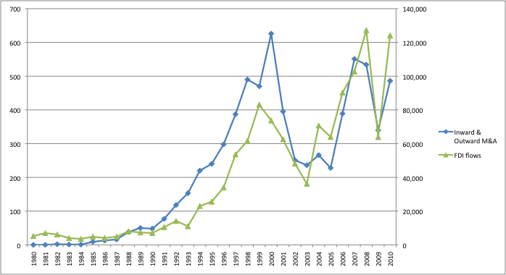
Chart 1 – Number of Inward and Outward M&A deals and FDI flows (in US dollars) - Argentina, Brazil, Chile and Mexico - 1980-2010

Source: Thomson SDC Platinum and UNCTAD

Chart 2 - Total number of M&A deals - Argentina, Brazil, Chile, Mexico and World - 1980-2010

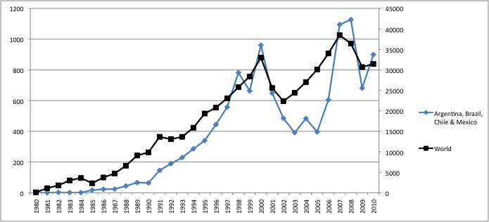
Source: Thomson SDC Platinum

Chart 3 - Total number of M&A deals - Argentina, Brazil, Chile & Mexico - 1980-2010

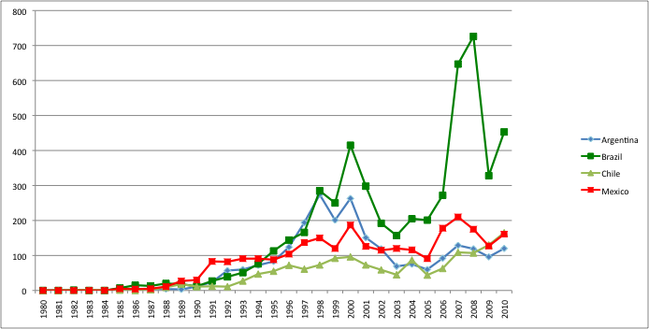
Source: Thomson SDC Platinum

Chart 4 - Total number of M&A deals - Brazil, China, India and World - 1980-2010

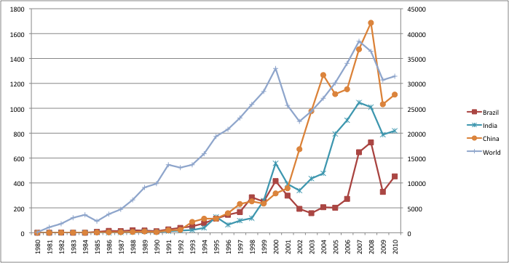
Source: Thomson SDC Platinum

Chart 5 - Total M&A activities - Argentina, Brazil, Chile, Mexico, China and India - Share World (%)

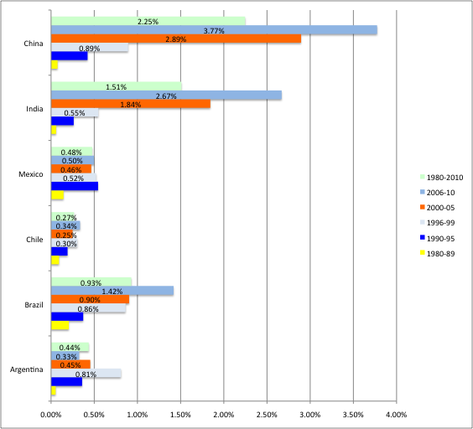

Source: Thomson SDC Platinum

Chart 6 - Aggregated of Domestic, Outward, Inward and Total M&A Deals for Argentina, Brazil, Chile and Mexico - 1980-2010 – number of deals

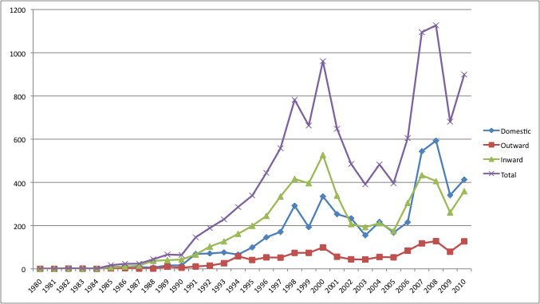
Source: Thomson SDC Platinum

Chart 7 - M&A Orientation: Argentina, Brazil, Chile, Mexico, China and India - 1980-2010

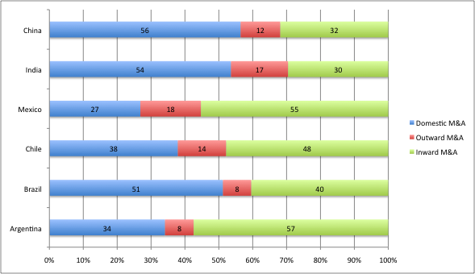
Source: Thomson SDC Platinum

Chart 8 – Domestic and outward M&A: Argentina, Brazil, Chile and Mexico - 1980-2010
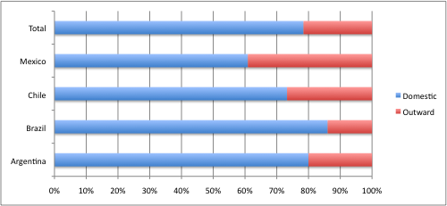
Source: Thomson SDC Platinum
Note: The figures presented in this chart are based on micro level data on domestic and outward deals for the four countries, and may reflect some differences in comparison to the aggregated figures presented in the previous section.

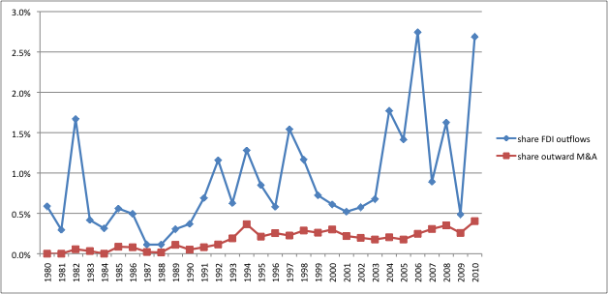

Chart 9 - Share FDI outflows & M&A outward of Argentina, Brazil, Chile and Mexico in the world totals- 1980-2010

Source: Thomson SDC Platinum and UNCTAD

Table 1 - Domestic and Outward M&A per country- 1980-Jun/2011

Country | Domestic |  | Outward
 | Number | % | Number | %
Argentina | 888 | 80.0 | 222 | 20.0
Brazil | 2765 | 86.6 | 449 | 14.0
Chile | 605 | 73.2 | 221 | 26.8
Mexico | 762 | 60.9 | 489 | 39.1
Total | 5020 | 78.4 | 1381 | 21.6
Source: own calculation based on Thomson SDC Platinum

Table 2 - Outward M&A by Argentina, Brazil, Chile and Mexico per period - number of deals and share
Period | Number | % Total Outward 1980-2011 | % Total M&A Activity within the period
1980-89 | 18 | 1.3 | 10.7
1990-95 | 156 | 11.3 | 12.4
1996-99 | 251 | 18.2 | 10.3
2000-05 | 359 | 26.0 | 10.4
2006-Jun/11 | 597 | 43.2 | 12.2
Total | 1381 | 100.0 | 11.3
Source: own calculation based on Thomson SDC Platinum

Chart 10 – FDI outflows (in US dollars) and number of outward M&As – Argentina, Brazil, Chile and Mexico – 1980-2010
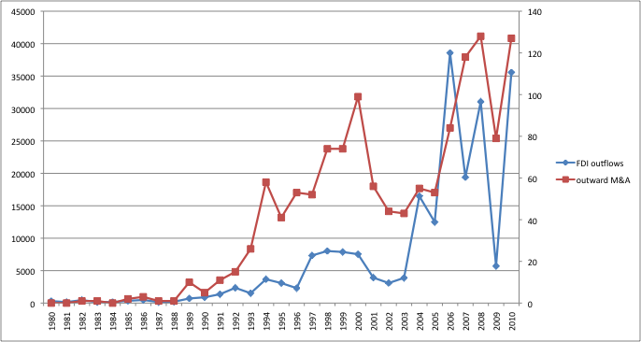
Source: Thomson SDC Platinum

Chart 11 – Sector of the target company – 1980-2011

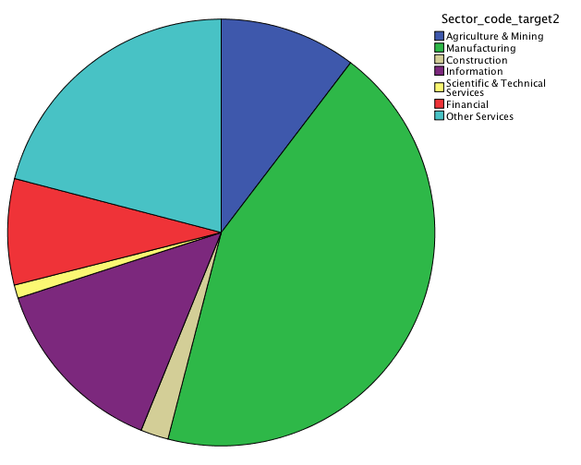

Source: Thomson SDC Platinum

Chart 12 – Technology intensity of manufacturing sector of the target company – 1980-2010

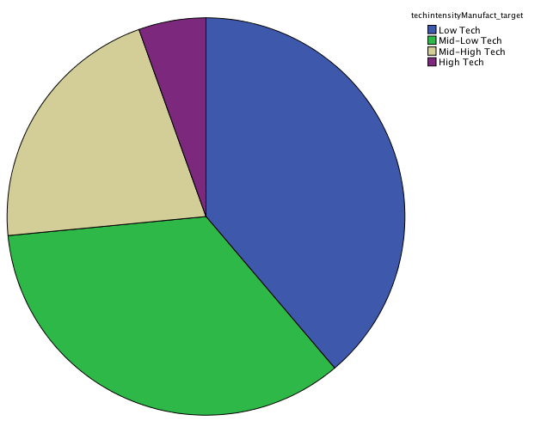

Source: Thomson SDC Platinum

Chart 13 – Target Region of outward M&A per period

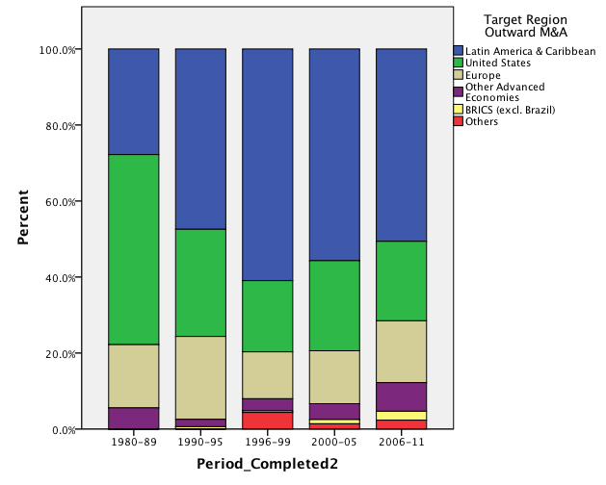

Source: Thomson SDC Platinum

Chart 14 – Target region and target sector – 1980-2011

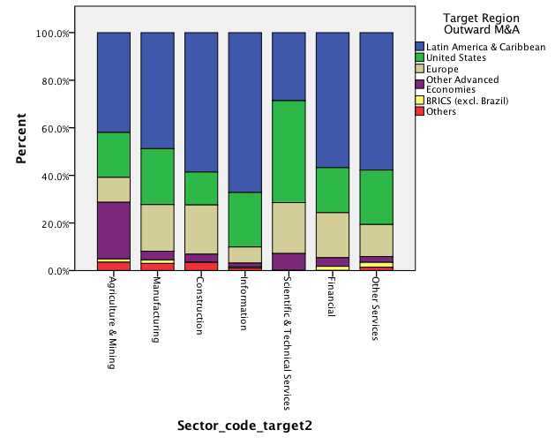

Source: Thomson SDC Platinum

Chart 15 – Target region and technology intensity of target manufacturing sector – 1980-2011

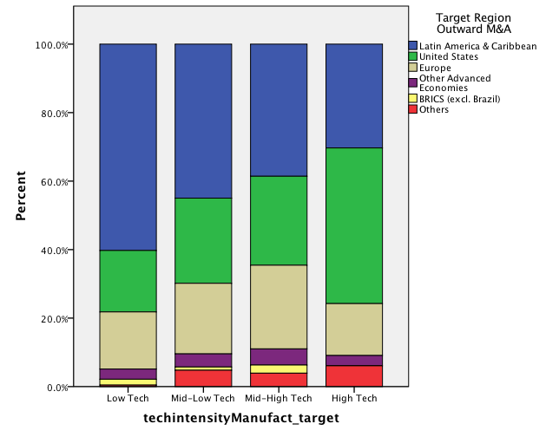

Source: Thomson SDC Platinum

The research leading to these results has received funding from the European Union Seventh Framework Programme (FP7/2007-2013) under grant agreement no. 275604.

