Margarete B. Bowien
ESADE Business School
Tel: +34 932 806 162 | Fax: +34 932 048 105 | Cell: +34 6632 41 135
Address: Av. Torre Blanca 59 | 08172 Sant Cugat de Vallès | Spain
Email: margarete.kalinowski@esade.edu

Luis Vives
ESADE Business School
Tel: +34 932 806 162 | Fax: +34 932 048 105 | Cell: +34 6198 74 053
Address: Avenida Esplugues, 92-96 | 08034 Barcelona | Spain
Email: luis.vives@esade.edu

abstract
The phenomenal surge in internationalization by firms from emerging markets has gained momentum in academic research. We contribute to the growing stream of research by exploring the questions of how EMNEs manage their business models as they internationalize and how they innovate their business models. We propose a conceptual framework depicted by two key variables: (1) the level of institutional difference in terms of entry into emerging or developed markets, and (2) strategic initiatives in terms of leveraging their own business models or developing new business models. The framework reveals four different business model management strategies EMNEs can pursue during their internationalization to other emerging markets or developed economies. We illustrate the framework using case study examples of different emerging multinationals. The paper concludes with theoretical and managerial implication and fruitful avenues for future research.

Keywords: Emerging Market Multinationals, Internationalization, Business Models

1. Introduction
Recent years have witnessed to a large degree the success story of the emerging markets multinationals (EMNEs). Companies such as América Móvil, the Mexican telecoms giant, Samsung, the South Korean electronics group, or Embraer, the Brazilian airplane manufacturer have become world-beaters – challenging their western rivals in the way they have developed technology and pursued innovation, transformed, innovated and managed their businesses models, and internationalized not only to other emerging and least-developed economies but more so to developed markets where they compete with Western firms on their home turf. The ascendancy of these emerging multinationals and their internationalization have gained increased academic attention in recent years (Aulakh and Kotabe, 2008; Aulakh, Kotabe, and Teegen, 2000; Bonaglia, Goldstein, and Mathews, 2007; Chittoor et al., 2009; Cuervo-Cazurra, 2007, 2008a; del Sol and Kogan, 2007; Gubbi et al., 2010; Hill and Mudambi, 2010; Khanna and Palepu, 2006; Lecraw, 1993; Mudambi, 2008; Ramamurti and Singh, 2009a; Sauvant, 2008; Young, Hunag, and McDermott, 1996; Special Issues of Journal of International Business Studies edited by Eden, 2010, and Luo and Tung, 2007; Special Issues of Journal of International Management edited by Aulakh, 2007, and Gammeltoft, Barnard and Madhok, 2010). This phenomenon of EMNEs’ internationalization is worthy of scientific scrutiny since it is occurring in a world that is very different from the past decades.

First of all, EMNEs have to overcome their globalization ‘late mover’ disadvantage (Bartlett and Ghoshal, 2000; Madhok, 2010), and they have to compete with established multinationals from the developed markets that have better access to strategic resources such as financial capital, advanced technologies and managerial, internationalization and competitive capabilities (Guillen, 2000). Further, EMNEs typically originate from unique institutional and resource environments (Hoskisson et al., 2000; Khanna and Palepu, 1997, 2006) characterized by market failure through information asymmetry, misguided regulations, inefficient judicial systems and weak legal frameworks, as well as strong institutional voids, which, in turn, increase transaction costs of accessing resources in the external markets and doing business in general (Chittoor et al., 2009; Ghemawat and Khanna, 1998; Khanna and Palepu, 1997; Madhok, 2010). Nonetheless, EMNEs succeed in overcoming their home market challenges. They respond well to exogenous shocks of regulatory and institutional reforms (Cuervo-Cazurra and Dau, 2009), pressures of new competition, opportunities offered by globalization, and transform themselves to become a sizeable and rising feature of the world economy (Duysters et al. 2009; Chittoor et al., 2009; Madhok, 2010) by creating innovative business models (Mudambi, 2008; Hill & Mudambi, 2010).

Research on agile EMNEs that combine novel business models with technological innovation has enriched our understanding of the value creating potential of EMNEs’ business model innovation (Govindarajan and Ramamurti, 2011; Immelt, Govindarajan, and Trimble, 2009; Sarkar, 2011). However, although many EMNEs are rapidly going global, both to better compete in international markets as well as be more competitive at home, relatively little is known about the internationalization processes and trajectories of these firms (Cuervo-Cazurra and Genc 2008; Peng, Wang, and Jiang, 2008). While some scholars argue that EMNEs follow an exploration strategy with the aim to acquire new advantages in order to overcome their home advantage deficit (Luo and Tung, 2007; Mathews, 2002) and their liability of emergingness (Madhok, 2010), others claim that EMNEs pursue exploitation strategies in order to leverage their existing firm and country specific advantages (Cuervo-Cazurra and Genc, 2008; Narula, 2006; Ramamurti, 2009a). This distinction has produced important insights, but is still incomplete in literature.

The objective of this paper is to participate in closing this research gap by extending the theoretical milestones of EMNEs’ internationalization through examination of business model innovation and management practices of EMNEs. The business model as reflection of the firm’s realized strategy (Casadesus-Masanell and Ricart, 2010) offers a particularly interesting insight in the context of EMNEs’ internationalization. Consequently, we concentrate on answering the following research questions: How do EMNEs manage their business models as they internationalize to developed markets and other emerging and least developed economies? How do EMNEs innovate their business models when they internationalize? This paper attempts to address these questions by proposing a conceptual framework derived from extant research, illustrated by eight case studies.

The study aims to make two contributions: 1) to add new insights to the theories of internationalization strategies and trajectories of emerging economy firms (Cuervo-Cazurra, 2007; Dawar and Frost, 1999; Khanna and Palepu, 2006; Luo and Tung, 2007; Madhok 2010; Ramamurti and Singh, 2009a), and 2) to add to the business model literature in the context of internationalization of emerging economy firms. The remainder of the paper is organized as follows. In the next section we establish the context by integrating insights from the relevant literature on EMNEs’ internationalization strategies and business models. We then propose a conceptual framework of how EMNEs manage their business models during internationalization into emerging and developed markets. We identify two key variables from extant literature: (1) level of institutional difference in terms of entry into emerging markets and developed markets, and (2) EMNEs’ strategic initiatives in terms of leveraging of traditional business models and the development of new business models. In the fourth section we explore the validity of our framework with illustrations of eight case studies of EMNEs internationalization trajectories and their business model management strategies. We conclude by drawing implications to theory and practice and offering directions for further research.

2. Theoretical Background
2.1 Emerging market multinationals and internationalization strategies
Emerging economies constitute unique institutional and resource environments (Hoskisson et al., 2000), characterized by institutional voids such as underdeveloped institutions and market intermediaries, and limited resources (Khanna and Palepu, 2006). Consequently, firms from emerging economies are limited in their growth by under-developed markets, low resource munificence, unsophisticated customers, sub-optimal suppliers, weak infrastructure, and market failure caused by information asymmetry, communication and information challenges, misguided regulations, inefficient judicial systems and weak legal frameworks (Khanna and Palepu 1997; Chittoor et al., 2009; Ramamurti and Singh, 2009a; Madhok, 2010). They also suffer of lower technological and managerial standards, underdeveloped capabilities and inadequate resources, as well as lack of experience in global competition (Cuervo-Cazurra and Dau, 2009; Ramamurti and Singh, 2009a). This liability of emergingness (Madhok, 2010) is internally further increased by the EMNEs’ small asset bases and the limited access to new strategic assets, which makes it difficult for them to scale advantages along the value chain activities vis-à-vis multinationals from developed markets. These disadvantages decrease efficiency and increase the transaction costs of EMNEs of accessing strategic resources and conducting business in general (Cuervo-Cazurra and Genc, 2008; Madhok, 2010).

A stream of literature focused on empirically testing the applicability of the popular typologies of competitive strategies at generic level (Miles and Snow, 1978; Mintzberg, 1978; Porter, 1980) in the context of EMNEs (Aulakh et al., 2000; Kim and Lim, 1988). Kim and Lim (1988) tested for the existence of Porter's (1980) generic strategies in the electronics industry in South Korea and found evidence for mixed strategies rather than pure types. Aulakh et al. (2000) found that cost leadership strategy was more successful in the case of exports to developed markets while differentiation worked better when developing economies were targeted. Taking into account the unique environmental and institutional context of emerging markets, there have been attempts in literature to develop specific conceptual models that propose a set of generic strategies available to EMNEs as they respond to institutional changes (Bonaglia et al., 2007; Craig and Douglas, 1997; Cuervo-Cazurra, 2007; Cuervo-Cazurra and Genc, 2008; Dawar and Frost, 1999; Khanna and Palepu, 2006). Craig and Douglas (1997) and Bonaglia et al. (2007) propose that the internationalization responses of EMNEs range from cost-oriented commodity approaches based on low-cost labor component and private-label manufacturing to higher value-creating approaches that capture a greater share of the value chain. Dawar and Frost (1999) identify a mix of defensive and assertive strategic options leveraging on some of the unique advantages and resources possessed by EMNEs. Khanna and Palepu (2006) and Cuervo-Cazurra and Genc (2008) suggest that EMNEs should exploit their advantage of managing institutional voids that characterize their local markets to counter multinationals from developed markets. Cuervo-Cazurra (2007) argues that EMNEs that benefit from a location advantage in their home market are more likely to start internationalization by using marketing subsidiaries, however, EMNEs that benefit from a location advantage in the host country or face difficulties in the transfer of products across countries are more likely to start internationalization by establishing production subsidiaries.

The common thesis underlying this past research is that EMNEs experience difficulties in developing resources and capabilities to compete with multinationals from developed markets and hence successful internationalization is only possible by means of exploitation of their country and firm specific ownership advantages, such as low costs or experience in operating within institutional voids, in other, similar, emerging or less developed economies. This stream of literature follows the argument that EMNEs, as well as experiencing disadvantages, also experience certain advantages (Dawar and Frost, 1999). Following the idea that the value of resources is contingent on time and location (Amit and Schoemaker, 1993; Brush and Artz, 1999; Hu, 1995; Tallman, 1992) and that a source of advantage can become later a source of disadvantage (Leonard-Barton, 1992), some scholars argue that despite their liability of emergingness (Madhok, 2010) deriving from underdeveloped institutional environments, EMNEs are successful in their internationalization (Cuervo-Cazurra, 2011; Curvo-Cazurra and Genc, 2008; Govindarajan and Ramamurti, 2011; Ramamurti, 2009a; Ramamurti and Singh, 2009a). EMNEs learn to work around institutional voids (Khanna and Palepu, 1997) and transform this home disadvantage into a source of relative advantage when they expand to other economies with the same or even more difficult institutional conditions (Cuervo-Cazurra and Genc, 2008).

Elaborating on the exploitation perspective, other scholars suggest that EMNEs possess a variety of other ownership advantages than just low costs or experience in operating within institutional voids (Guillen and Gracia-Canal, 2009; Lessard and Lucea, 2008; Williamson and Zeng, 2008), which translate into significant competitive advantage in local markets and in other emerging markets (Ramamurti, 2009a, 2009b; Sim and Pandian, 2003), such as profound knowledge of underdeveloped and low-income consumers, human capital in the form of entrepreneurial skills and international social networks, such as links with the diaspora, large labor pools and home markets, ability to adapt imported technology to develop products suited to the special needs of local customers in emerging markets, ability to optimize production processes by using more labor and less capital, and in some cases the support from the home government in the form of preferred access to markets, preferential regulations, or preferred access to capital (Lall, 1983; Lecraw, 1977; Ramamurti, 2009a; Ramamurti and Singh, 2009a; Wells 1983; Williamson and Zeng, 2008). In their analysis of twelve Taiwanese and Singaporean firms, Sim and Pandian (2003) found that the EMNEs’ strategic advantages derived from low cost, responsiveness and knowledge of local markets.

While traditional views on internationalization are embedded in the exploitation perspective, which explains that firms make the most of their rent yielding ownership advantages through internationalization into foreign markets (Buckley and Casson, 1976; Hymer 1976), recent stream of literature argues that EMNEs rely too heavily on their country and firm specific advantages for their international competitiveness (Rugman, 2009) and that they possess only ‘ordinary resources’ (Madhok, 2010) or only few intangible ownership advantages, such as brands and technology (Ramamurti, 2009a, 2009b). These recent studies follow the exploration perspective where EMNEs internationalize motivated by gaining access to and internalize strategic resources (Capron, Dussauge, and Mitchell, 1998; Ethiraj and Levinthal, 2004; Gubbi et al., 2010; Madhok, 2010) in order to reduce their emerging market home-country effect (Cuervo-Cazurra, 2011), enhance their strategic renewal (Nelson, 2005; Gubbi et al., 2010), and facilitate quicker transformation by enabling transfer of status and reputation which helps EMNEs to overcome the liabilities of emergingness in global markets (Madhok, 2010). EMNEs acquire financial capital and management skills (Lyles and Baird, 1994; McDonald, 1993; Stoever, 1996), as well as other intangible assets, such as technology, brands, and know-how to establish presence as world-class players (Aulakh, 2007; Luo and Tung, 2007; Madhok, 2010; Mathews, 2002).

Such inorganic growth through acquisitions in developed markets offers EMNEs the possibility to leapfrog conventional growth cycles and permits rapid internationalization of intangible resources, which are difficult to trade through market mechanisms, take time and are path dependent to develop internally (Coff, 1999; Gupta and Govindarajan, 2000). Acquisitions facilitate quicker transformation by enabling transfer of status and reputation which help EMNEs to overcome the liabilities of emergingness in global markets and allow the integration of new and diverse organizational practices with their traditional management techniques (Vermeulen and Barkema, 2001; Uhlenbruck, Hitt, and Semadeni, 2006; Cuervo-Cazurra, Maloney, and Manrakhan 2007).

Chittoor and Ray (2007) studied internationalizing firms in India and they too found evidence of firms' international expansion driven by exploitation of local advantages, but they also found equally compelling evidence of firms rapidly exploring and acquiring resources and capabilities to develop state-of-the-art products and move up the value chain. The implication is that EMNEs not only pursue different strategies in their international expansion, but they do so with different core logic of how to operate in different institutional environments. This turns the spotlight on the business model as the core logic of how firms operate, create and capture value (Baden-Fuller et al., 2010; Demil and Lecocq, 2010) that reflects the firm’s realized strategy (Casadesus-Masanell and Ricart, 2010). EMNEs not only expand to foreign markets with distinctive business models but they also manage their business models differently in the different markets under different conditions. In light of EMNEs’ increasing global presence and competitiveness with Western firms, the business model concept offers a particularly interesting insight into the context of EMNEs’ internationalization.

2.2 Notion of the business model
The business model is a useful notion that enhances the understanding, labeling and classification of firms’ operations (Baden-Fuller and Morgan, 2010). In its broadest sense, the business model constitutes the firm’s architectural backbone (Shafer, Smith, and Linder, 2005). It is defined as the core logic of how the firm operates, creates and captures value (Baden-Fuller et al., 2010; Casadesus-Masanell and Ricart, 2010; Demil and Lecocq, 2010). Thus, the business model is the design of transaction content, structure, and governance so as to create value through the exploitation of business opportunities.” (Amit and Zott, 2001) and as such it acts as an activity system that allows the firm to create and capture value, depicted as a set of activities, resources, and the way they are organized (Svejenova, Planellas, and Vives, 2010; Zott and Amit, 2010). As the core logic of how the firm operates the business model has received increasing attention from scholars interested in explaining firms’ value creation and appropriation, preferential firm performance, and competitive advantage. Scholars acknowledge that firms do not employ and execute their business models in a competitive vacuum but instead compete through their business models (Zott and Amit, 2007, 2008; Casadesus-Masanell and Ricart, 2010). Business models serve as representations of firms’ underlying strategic choices (Casadesus-Masanell and Ricart, 2010; Shafer et al., 2005). The design of the business model is a crucial decision to be taken by firms to ensure that their business models are rethought in order to adapt the firm to a new business environment (Zott and Amit, 2010). The competitiveness of EMNEs in new markets is related to how their business models interact with the new environments, producing offerings that add value to the participants in these environments (Casadesus-Masanell and Ricart, 2010).

The activity system perspective on business models takes a configurative approach to describe the internal relationship among activities (Afuah and Tucci, 2001). It describes how the pieces of a business fit together (Magretta, 2002). As such, the activity system refers to any number of practices that allow the business model to better utilize its inputs and achieve excellence in individual activities, resources and their organizing (Hedman and Kalling, 2003; Santos, Spector, and Van der Heyden, 2009; Svejenova et al. 2010; Zott and Amit 2010). It is a complex set of interdependent activities that are ‘discovered, adjusted, and fine-tuned by doing’ (Winter and Szulanski 2001, p. 731). They can lead to the creation of new strategic resources and open up alternatives for future value creation and appropriation. The internal fit among activities ensures that the business model has a coherent configuration of activities, while external fit refers to the appropriateness of the configuration of activities given the environmental conditions affecting the business model (Siggelkow 2001). Adding or removing activities and resources is about changes in the scope of the business model and “changing the scope of the organization not only affects the extent to which it can capture the fruits of its innovative labor; but it also affects the extent to which it can be innovative in the future” (Jacobides, Knudsen, and Augier, 2006). The business model plays a particularly important role in the context of EMNEs expanding to foreign markets.

EMNEs modify and reconfigure their activities and resources in ways that enable them to operate in other challenging institutional environments (Vermeulen and Barkema, 2002) and compete against larger MNEs from developed countries (Dawar and Frost, 1999), but also acquire strategic resources in developed markets (Madhok, 2010). The level of the institutional environment in a market directly affects the firm’s incentives and ability to reconfigure its resources and activities (Cuervo-Cazurra and Genc, 2008) by challenging the external fit between the business model and the external environment (Nelson, 1995) that in turn facilitates, or challenges, transactions (North, 1990). Thus, the market development as the degree to which capital and labor markets, legal systems, and commercial value chains are established and developed in support of business activities (Chakrabarti, Vidal, and Mitchell, 2011; Cuervo-Cazurra and Dau, 2009) impacts the design and management of EMNEs’ business models. Differences in institutional environments across countries lead to different strategic initiatives (Chakrabarti et al., 2011). Since business models are the reflections of realized strategies (Casadesus-Masanell and Ricart, 2010) the different internationalization strategies pursued by EMNEs lead to different reconfigurations of the business model’s activity system and to different business model management strategies.

External reconfiguration of resources through acquisition of businesses allows firms to gain access to strategic resources and develop new capabilities while preventing organizational inertia (Rosenkopf and Nerkar, 2001; Vermeulen and Barkema, 2001). Creation of new advantages through external reconfiguration allows EMNEs to redeploy newly obtained managerial and financial resources (Capron et al., 1998), create new process for future growth (Capron and Mitchell, 2009), and enable EMNEs to change faster and at a broader scope as opposed to internal development of activities, resources and capabilities (Karim and Mitchell, 2000). Internal reconfiguration of the activity systems allows EMNEs to expand through the exploitation of their firm-specific advantages, competencies and knowledge (Caves, 1974; Helfat, 1994) by leveraging their own traditional business models to other markets. EMNEs are able to capture large portions of their value creation by reconfiguring resources and activities in their business model in ways that suit the specific institutional and market conditions in emerging economies (Khanna and Palepu, 1997), which they exploit and internally reconfigure while expanding to foreign markets (Ramamurti and Singh, 2009a). Some scholars claim that the more a firm excels in some competencies and a particular design of the business model, the more it is likely to exploit those competencies and the business model instead of developing a new one (March, 1991). Firms tend to understand internal routines better than acquired ones (Karim and Mitchell, 2004; Wiersema and Bowen, 2011) and usually favor the familiar (Ahuja and Lampert, 2001; Christensen and Bower, 1996).

Extant literature implies that emerging and developed markets require fundamentally different business models and business model management strategies due to the differences in institutional infrastructure, market development, customer demands and needs, as well as resource availability and external fit with the environments. Firms operating in these distinctive markets differ in their core logics of value creation and appropriation and consequently they organize their activity systems differently according to the complexity of the environmental context, interconnectedness of the ecosystems and the underlying strategic initiatives.

3. Internationalization and Business Model Management
3.1 Conceptual framework
From the review of extant literature we conclude that rather than adopting an either/or perspective, we are be better off approaching the topic of EMNEs’ internationalization from a contingency perspective. This idea is used in Figure 1, which classifies EMNEs’ internationalization strategies along two dimensions. Specifically, from the literature review we identify two key variables that influence how EMNEs internationalize and how they manage their business models during internationalization: (1) degree of institutional difference with regard to entry into an emerging market or a developed market; and (2) EMNEs’ strategic initiatives in terms of either leveraging their traditional business model through the exploitation of ownership advantages or developing new business model through the acquisition or development of new advantages. When we plot these two dimensions in a matrix (Figure 1), we obtain four possible internationalization strategies and business model management alternatives EMNEs pursue. Conceptually, this can be generalized into four broad types of business model management as internationalization trajectories for emerging economy firms: 1) leveraging of traditional business model in other similar emerging markets, which is based on pure exploitation strategy hinging on ownership advantages similar to existing ones in markets similar to the domestic market; 2) leveraging of traditional business model in developed markets, which is based on exploitation of ownership advantages in new developed markets and an internationalization strategy based on exploration of new markets through the same products and service offerings; 3) developing new business model in other similar emerging markets, which is based on exploration of new advantages through new product and service offerings in similar markets; 4) developing new business model in developed markets, which hinges on a pure exploration strategy involving new products and service offerings and new developed markets.
----------------------------------
Insert Figure 1 about here
----------------------------------

3.1.1 Leveraging of traditional business model in emerging markets
EMNEs design and innovate their business models at home (Ramamurti and Singh, 2009a) in the way their products and services are financed, distributed, and sold in emerging markets because of various institutional voids that characterize their home market (Khanna, Palepu, and Sinha, 2005). When EMNEs internationalize to other emerging markets by leveraging of their traditional business models (Figure 1, cell 1), based on the exploitation of their own country and firm specific advantages, they follow a single business model strategy. They maintain the value proposition offered to customers in the home market, the way their capture value for the firm, and the way the firm’s activities and resources are organized in the business models, which demonstrated a strong external fit between the activities and resources of the firm and the challenging institutional environment in the domestic market. There is always a potential need for a marginal business model adaptation, but the core traditional business model developed in the home market remains. EMNEs expand their traditional home business model and employ it in other emerging markets where they are familiar with the similar institutional environment and know how to operate within such.

3.1.2 Leveraging of traditional business model in developed markets
Literature argues that EMNEs have only ‘ordinary resources’ (Madhok, 2010) and only few intangible ownership advantages, such as brands and technology (Ramamurti, 2009a; Ramamurti and Singh, 2009b), and they are more familiar with conducting business and operating in difficult institutional environments in emerging economies (Cuervo-Cazurra and Genc, 2009). Yet, EMNEs enter developed markets by leveraging their traditional business models from home (Figure 1, cell 2). The strong institutional infrastructure and greater market development present in developed markets facilitate higher degree of internal and external reconfiguration of resources and activities in EMNEs’ business models (Khanna and Palepu, 1999). It allows EMNEs to leverage their own business model into developed markets, acquire complementary resources, and integrate them fast into their own business model. The main objective is to acquire strategic resources for further international expansion, such as for instance developed markets MNEs’ financial resources, credit rankings, and managerial skills.

In order to create and appropriate more value EMNEs that enter developed markets via a single business model strategy by leveraging their own business models do so by first developing innovative and better business models at home to roll out to many different markets in developed economies. Despite the resources disadvantage, some EMNEs are able to reconfigure their activities and resources internally and externally through acquisition in a way to increase value creation and value capture in emerging markets and exploit these business models in developed markets as well by focusing on needs of lead customers in developed markets. Other EMNEs enter developed markets by leveraging their traditional business models designed around the creation of value products and service offerings. Since emerging economies differ from developed economies in the per capita income of average consumers the mass consumer markets in emerging economies, except for the top of the pyramid in these markets, thus require business models based on value products and services characterized by low cost, functionality, different price-performance value proposition, and ‘good-enough-quality’ that demand different competencies (Govindarajan and Ramamurti, 2011; Ramamurti, 2009a). There are low to mid-end consumers in developed markets for whom the ‘good-enough-quality’ products at low prices have appeal. This is the mirror image of the assumption many multinationals from developed markets predicate their strategies on, namely that products from developed markets have appeal to consumers at the top of the pyramid in emerging markets (Govindarajan and Ramamurti, 2011). Aligned with business models designed around value offerings, EMNEs leverage successfully their own traditional business models from home by moving up the value chain. They transform their business models by moving up the value chain from original equipment manufacturers selling their own products with a Western firm’s brand affixed to original design manufacturers or original brand manufacturers leveraging their value business models in developed markets through foreign direct investment (Bongalia et al., 2007; Duysters et al., 2009).

3.1.3 Developing new business model in emerging markets
EMNEs expand to other emerging markets to explore new advantages by developing new business models (Figure 1, cell 3) when the fit between the EMNEs’ traditional business model and the new external environment is not strong enough. External reconfiguration of activities and resources in emerging markets is challenging when the institutional infrastructure is weak and acquisitions cause valuation difficulties and opportunistic behavior by contracting parties, which reduces EMNEs’ ability to buy and sell (Capron et al., 1998; Chakrabarti et al., 2011), driven by information asymmetry (Arikan, 2005; Madhok, 2010; Reuer and Ragozzino, 2008) and weak patent and other appropriability standards (Chi, 1994; Grossman and Hart, 1986; Rumelt, 1987; Williamson, 1985). Yet, due to the difficulties in acquisitions in challenging institutional environments of emerging markets EMNEs expand to those markets by transforming their own traditional business models into new ones in order to adapt to the voids prevailing in the other emerging markets they expand to.

The external reconfiguration of the activity system through acquisition and development of new resources and activities leads to new innovative business models and higher value appropriation in other emerging markets. EMNEs modify their business models without destroying the elements of the activity system that give them a competitive advantage over competitors. They identify the value proposition that they will not modify, whatever the context (Govindarajan and Ramamurti, 2011). The transformation of the traditional business model depends on the customers and institutional conditions in the new emerging market, the product/ service the EMNE desires to offer in the new market, or the target business it has acquired in order to enter into the market. Here, EMNEs enter the new emerging market by transforming their own business models initially and managing dual business models before eventually integrating them into a new business model.

3.1.4 Developing new business model in developed markets
EMNEs face constraints when pursuing internal reorganization of activities and resources due to lack of strategic resources and well-developed supporting resources, such as availability of complementary resources (Mitchell, 1989) and skilled personnel (Penrose, 1959), which are scarce in emerging markets (Peng and Heath, 1996; Puffer, 1992; Sharma, 1993). In their attempt to overcome those constraints EMNEs expand to developed markets with the development or acquisition of new business models (Figure 1, cell 4) with the objective to get access to complementary and strategic resources, and reconfigure, upgrade and develop new capabilities to produce advanced value-added products and services required in globally competitive product markets (Aulakh, 2007; Bonaglia et al., 2007; Chittoor et al. 2009; Duysters et al., 2009; Madhok, 2010; Matthews, 2006). The stronger institutional infrastructure and greater market development present in developed markets facilitate and encourage a higher degree external reconfiguration of resources and activities in EMNEs’ business models (Khanna and Palepu, 1999). Here, EMNEs pursue the strategy of dual business model management and internationalize with two separate business models, the traditional business model in the home market and a new, independent business model developed or acquired in the developed market.

This dual business model strategy is pursued when efficiency is not the main driver but instead the motivation to explore and seek new opportunities. Since EMNEs do not have superior advantages to be transferred to the acquired firm as typically argued in literature (Nachum 2003), EMNEs’ greater concern is how to overcome their liability of emergingness and to learn and upgrade firm capabilities (Madhok, 2010). Furthermore, integration of the acquired target’s business model into their own activity systems is also less desirable since EMNEs are motivated by the learning opportunities and access to strategic resources rather than costs and efficiency unlike multinationals from developed markets. A recent study found that more than 50 per cent of Asian EMNEs do not integrate to any significant extent since their priorities and motives are quite distinct than acquirers from developed economies (Cogman and Tan, 2010). EMNE’s aspired learning has less to do with technology alone but with management, organizational know-how, and aspects concerning the institutional environment in developed markets.

3.2 Internationalization and business model management: Case study illustrations
We explore the validity of our conceptual framework through illustrations of case studies of eight EMNEs (Table 1, Figure 2). Figure 1 is designed to suggest that we are better off adapting a contingency perspective rather than an either/or perspective when exploring EMNEs’ internationalization, not to suggest that the world can be neatly divided into four quadrants. These four distinctions of internationalization strategy are important because they give us insight into why some EMNEs are successful in expanding to other markets and why others fail, as well as how EMNEs transform and innovate their business models during internationalization. The framework further contributes to research by advancing our understanding that internationalization of EMNEs is not just about either exploitation of ownership advantages or exploration of new advantages.
----------------------------------
Insert Table 1 about here
----------------------------------
----------------------------------
Insert Figure 2 about here
----------------------------------

3.2.1 Leveraging of traditional business model in emerging markets
Internationalization directed toward other emerging countries by leveraging the own traditional business model is a way to diversify away from the domestic market into similar markets while maintaining the domestic market as the primary market (Lall, 1983). This is the approach followed by América Móvil, the Mexican mobile company, which has grown sixfold since its spin-off from former state-owned monopoly, Teléfonos de México (Telmex) in 2000 by crafting a successful pre-paid and call-card business model for markets with low-income consumers who lack a positive credit rating. This business model allowed the company to unlock shareholder value and provided a branding vehicle to expand its wireless business (Casanova, 2009). América Móvil leveraged its business model across other emerging markets by acquiring distressed companies and integrating them into their activity system. It employed its business model in other emerging markets by exploiting its capability to serve the low-income customer base.

India’s Tata group companies follow the same single business model strategy in other emerging markets. They leverage their traditional business models in the different product groups across different emerging and least developed economies with the objective to expand its market. For example, Tata Motors produces trucks without technologically advanced components and systems but with strong and rigid suspension system that can withstand the challenges of India’s unpaved, rutted rural roads. These vehicles can be easily maintained and repaired by locals without formal training in mechanics, while the necessary spare parts do not pose any constraints. Therefore, Tata Motors was able to expand its trucks business models to other developing countries such as Tanzania, Zimbabwe, Malawi, Namibia, Mozambique, Uganda, Ghana and South Africa (Veliyath and Brouthers, 2010).

3.2.2 Leveraging of traditional business model in developed markets
Leveraging of their traditional business models into developed markets and not just emerging markets are the approaches of Cemex from Mexico, which is one of the world’s biggest suppliers of ready-mix concrete, and Embraer from Brazil, which is a manufacturer of commercial aircrafts. Both companies successfully developed innovative business models by reconfiguring the activities and resources in the traditional business models at home and expanded then successfully their business model innovation to developed markets following a single business strategy. For example, the position that the Brazilian Embraer enjoyed in recent years in commercial aircrafts for commuter and regional airlines demonstrates how business model innovation of its traditional business model in the commercial aircraft business at home was a key in turning the performance of an existing and relatively unknown player in the industry into global leadership. Embraer performed business model innovation by reconfiguring its existent activities and resources in the activity system: change of relations with suppliers into risk-sharing partnerships, co-design of components by suppliers and Embraer together very early on in the development process, outsourcing of ancillary design and production activities to local companies, focus on US customers as lead customers instead of local customers in Brazil, and outsourcing of some major design and production activities to suppliers outside of Brazil (Santos et al., 2009). In its business model innovation Embraer focused from the beginning on the needs and trends of lead customers in developed markets and orchestrated accordingly all its activities and resources as a consortium of strategic suppliers from different countries with the objective to assemble, sell, and service its commercial aircrafts in developed markets. The key elements of Embraer’s business model, since it was a protected state-owned company, which the firm managed to leverage to other developed markets were its capability to design planes, produce fuselage and assemble the final product, relying on the delivery of foreign suppliers, and a strong focus on customers’ needs and their market environments (Casanova, 2009).

When EMNEs enter into developed markets by leveraging their own business models they integrate the reconfigured activity system into their traditional business model to take better advantage of the newly acquired capabilities and knowledge and increase efficiency. This is the approach is used by Cemex, the Mexican cement production giant and major global player. Its internationalization into developed markets by leveraging its traditional business model began with the acquisition of two Spanish cement producers in 1992, which had an investment grade sovereign rating and thus allowed Cemex to improve its credit rating, raise capital in international financial markets to fuel further acquisitions, consolidate its group-wide debts into the Spanish subsidiaries where interest rates were tax-deductible in Spain, and it opened a back door through which Cemex could export cement to the US without having to pay heavy duties (Casanova, 2009). This set the stage for the firm’s fast internationalization to other developed markets. Cemex’s has developed a business model, which allows the firm to externally reconfigure its activities and resources in the activity system by integrating its acquisitions into the business model quickly and efficiently in order to further leverage its business model in other developed markets.

3.2.3 Developing new business model in emerging markets
Enka Holding, Turkey’s biggest construction company develops new business models in other emerging markets where it is easier for the firm to win contracts. While maintaining its value proposition, the firm reorganizes its activity systems and enters other developing markets with the development of new business models. Enka enters new emerging markets with new business models designed for the specific market by opening subsidiaries and reconfiguring its activities and resources to transform its business model to fit the new institutional environments. For example, through Mosenka, Enka’s Russian arm, Enka has become the biggest private real-estate owner in Moscow, and one of the city’s leading developers (Munir, 2002).

Another example is Brazil’s Natura Cosméticos. The company follows a direct sales business model in the domestic market. This EMNE enters other emerging markets by transforming its traditional direct sales business model into a new retail based business model following a dual business model strategy when it cannot leverage its direct sales model. For instance, when entering Chile Natura Cosméticos was forced to transform its direct sales model with beauty consultants and develop a retail sales business model because customers in Chile purchase their cosmetics and hygiene products in retail stores and not through consultants, which is also the case in other markets. Such transformation of the business model results in the internal reconfiguration of the firm’s activities of distribution, sales, and marketing. Thus, the company follows a dual business model strategy. While it maintains and leverages its traditional business model to markets where it can exploit the direct sales model to create and capture value, at the same time it develops new business models in other emerging markets to create and capture value.

3.2.4 Developing new business model in developed markets
This is the approach followed by India’s Tata Group spanning a wide range of industries, from hotels, tea, chemicals and metals to consulting, auto components, and automobiles. Tata Group’s different companies expand to developed markets by acquisition of leading firms in their industries. Based on the nature of the business, these investments in Western markets have different strategic objectives: accessing new markets (BPO, steel, cars, trucks); integrating value chain (steel); brand control (tea, cars); and technology acquisition (steel, cars, trucks) (Goldstein, 2008). Tata externally reconfigures its activity systems by acquiring strategic resources such as managerial, technological, and marketing resources without having to develop them internally. EMNEs develop new business models in Western markets through acquisitions, however, because of the group’s interest in learning from the acquired companies and overcoming its liability of emergingness (Madhok, 2010) the group does not integrate its acquisitions into its business models and maintains operations in diverse locations following a dual business model strategy.

For example, in 2007 Tata Motors acquired Jaguar and Land Rover, two luxury car brands with their major markets being USA and European countries. At the same time, Tata Motors could not really be termed a global brand with majority of its revenues coming from India. The development of the new business model through the acquisition transformed Tata Motors into a global player and gave the company access to technology expertise, offered access to new markets, and allowed the firm global brand control. Chinese Lenovo also followed a dual business model strategy when the company acquired IBM’s PC division and became overnight an international company. Instead of incorporating IBM’s PC division’s business model into its own activity system Lenovo employed two separate business models, its traditional activity system in China and the acquired business model in the US (Vives and Lessard, 2006).
----------------------------------
Insert Table 2 about here
----------------------------------

4. Discussion
Recent wave of internationalization sparked new interest in firms from emerging markets making it an important research topic in international business (Buckley, 2002). The article argues that EMNEs follow different internationalization strategies to emerging and developed markets depending on the degree of institutional difference and endowments of own resources and activities. In this article we have proposed a conceptual framework and argue that during internationalization by firms from emerging markets, under certain circumstances, the dual business model strategy is preferable to the single business model strategy, but under certain other circumstances, the single business model strategy might be preferable to dual business model management. Specifically, we have argued that the dual business model strategy is the preferred strategy when EMNEs enter emerging and developed markets by developing or acquiring new business models and the new market is not only strategically different from the EMNEs domestic market but also when the two business models face serious tradeoffs and conflicts. While the firm explores new advantages it is crucial to exploit the newly developed and acquired advantages and strategic resources such as for example brand equity, financial resources, and managerial and competitive expertise.

Entry into emerging and developed markets via a single business model strategy by leveraging the traditional business model is necessary when the new market is very similar to the domestic market and presents few conflicts that need managing. In such a case, embracing the new business model through the EMNE’s existing activity system is the superior internationalization strategy. Here the firm needs to strive to protect the business model and exploit its advantages and synergies. We have also described the circumstances when EMNEs need to innovate the business model at first before entering into a developing market by leveraging their business model and integrating it with the existing activity system in order to follow a single business model strategy in developed markets. In similar terms, when EMNEs enter into other emerging markets by developing new business models the preferred strategy is to first transform the traditional business model in the new markets and manage two separate business models at first before eventually integrating them with the existing activity system. We have therefore proposed that the best way to approach the topic of internationalization by firms from emerging markets is through a contingency perspective.

EMNEs expanding across border need to understand their business models and how their activities and resources are organized in the activity systems. The business model acts as the core logic of how a firm conducts business, how it delivers value to stakeholders, and how it links factor and product markets in domestic and foreign markets. The architecture of the EMNE’s activity system – the choice of activities, how the activities and resources are organized, and who performs them (Svejenova et al., 2010; Zott and Amit, 2010) – captures how the EMNE is embedded in its ecosystem of multiple networks of suppliers, partners, customers, and competitors in the domestic market as well as in the foreign target market.
It describes how the activities are linked, e.g. the sequencing between them, and it captures their importance for the business model in terms of their core, supporting or peripheral nature (Siggelkow, 2001, 2002; Zott and Amit, 2010). For example, a hardware supplier from an emerging market faces challenges leveraging its traditional business model to a new foreign market due to the influence of its home market institutions. By placing the focus on its business model and its underlying activity system the firm can identify its core and peripheral activities and for instance shift activities from being a hardware supplier (old core) to becoming a service provider (new core). This internal reconfiguration of the activity system allows the company to enter a new foreign market with a modified business model and overcome the challenges that the firm faced as a hardware manufacturer during its internationalization. Thus, by shifting the focus away from country and firm specific advantages that EMNEs experience or have a lack of toward the business model as a boundary-spanning concept opens new areas for theorizing on internationalization strategies for firms from emerging markets.

4.1 Theoretical implications
The findings presented in this paper have important implications for theory and practice. In contrast to the extant theorizing on the internationalization strategies likely to be adopted by emerging economy firms (Cuervo-Cazurra and Genc, 2008; Dawar and Frost, 1999; Khanna and Palepu, 2006; Madhok, 2010), the findings indicate that firms from emerging markets do not necessarily follow an either exploitation or exploration strategy. In this sense, this study supports the research by Chittoor and Ray (2007) arguing that EMNEs internationalize through a combination of exploitation and exploration strategies determined by their business model design, innovation and management. Our theoretical implications, taken together, support theoretical conjectures in the literature that EMNEs use internationalization as a springboard to acquire strategic assets from diverse markets in order to overcome their many disadvantages and become more competitive during periods of institutional transitions (Hutzschenreuter, Pedersen, and Volberda, 2007; Luo and Tung, 2007; Mathews, 2006), but they also support the traditional theoretical conjectures in literature that EMNEs internationalize through the exploitation of their ownership advantages (Ramamurti, 2009a) by leveraging and innovating their own traditional business models . Our findings suggest that internationalization through business model management, with the underlying resources and capability reconfigurations in the activity systems, facilitate strategic and organizational transformation of these firms.

The resulting explanations help us better understand how business models interact with the external environment during EMNEs’ internationalization and how these firms overcome their home market challenges and advantage deficits by reconfiguring their activity systems. International markets serve as means to gain access to diverse, locally embedded ideas and knowledge-based capabilities (Almeida, 1996; Doz, Santos, and Williamson, 2001). The institutional environment of countries is determined by the sets of rules and regulations that direct the economies (North, 1990). Thus, every institutional environment offers different advantages, opportunities and challenges. Over time, organizations learn to operate in particular institutional environments (Eriksson et al., 1997; Johanson and Vahlne, 1977) and manage their relationships with their external environment (Cuervo-Cazurra and Genc, 2008). Majority of studies in the management literature study the influence of host country institutions on the entry of foreign multinationals from developed markets (Bevan, Estrin, and Meyer, 2004; Henisz, 2000). New streams of literature discuss how home country institutions influence the market entry of multinationals from emerging economies and their competitive behavior in foreign markets (Cuervo-Cazurra, 2011; Cuervo-Cazurra and Genc, 2008; Rangan and Drumond, 2011). This study contributes to the literature by adding a new dimension, namely the internal notion of the business model. By reconfiguring their activity systems internally and externally EMNEs use the internal driving force of their business models to overcome home and host country influence. The conceptual paper contributes to the present theory on internationalization of EMNEs by adding new strategic alternatives EMNEs can pursue in addition to the pure exploitation in other emerging markets and exploration in developed markets perspectives.

Another theoretical implication of the evidence presented in this paper is that EMNEs are a unique kind of multinationals than can only be understood adequately with de novo theory as suggested by Mathews (2002). Existing international business theory is adequate and sufficient to help answer questions regarding why EMNEs internationalize, what challenges they face in host countries, and when they prefer hierarchies over markets (Ramamurti, 2009a). However, existing international business theory falls short in answering questions about competitive advantages of EMNEs and where those advantages derive from, why some EMNEs follow substantial outward foreign direct investment strategies, and why some EMNEs compete successfully against established Western multinationals. By introducing the notion of the business model the proposed conceptual framework helps advance answers to issues in EMNEs research for which existent international business theory falls short in providing.

4.2 Managerial implications
This paper also provides practical and managerial implications. It is important for managers to understand how firms from emerging markets enter into new foreign markets and what are the implications of different business model management strategies in different markets and the underlying objectives. The presented conceptual framework allows managers of EMNEs to better understand how to expand to new markets in terms of leveraging the traditional business model, innovate or transform the business model, or enter new markets through the development or acquisition of an entirely new business model. Each business model management strategy bears different consequences for the firm and requires different organization of the activity system, which in turn has implication for the value creation and value capture mechanisms.

Further, our proposed framework allows managers to believe that their firms are not necessarily at a disadvantage relative to their competitors from developed markets, but that they also can develop greater advantage vis-à-vis Western rivals. The presented conceptual framework encourages managers to evaluate the internationalization of EMNEs from the business model perspective in terms of the core logic of how EMNEs create and capture value and how they organize their activities and resources. The notion of the business model allows EMNEs to focus on the core logic of how to operate and reconfigure their activity systems internally or externally depending on the context in emerging and developed markets. Leveraging of the traditional business model from home and the development of new business models have different competitive consequences because they require quite different organizational capabilities and follow different strategies; that is, EMNEs require different abilities to absorb, integrate, and transform internal and external resources and activities into a competitive advantage (Amit and Schoemaker, 1993).

Moreover, the notion of the business model in the context of EMNEs’ internationalization allows managers to understand how activity system reconfiguration processes during their internationalization lead to the acquisition or development of distinctive competences and strategic resources, which, if sustained and leveraged over time, can bring opportunities for further business model development. Such newly developed or acquired distinctive competences and strategic resources help refine the business model’s core logic of value creation and appropriation, or create opportunities for diversification through changes in the business model architecture, which is particularly important for further internationalization to other foreign markets.

4.3 Avenues for future research
Our study has a number of limitations and also leaves a number of open questions that may well be the source of further research. Firstly, this study has essentially been an exploratory one, analyzing an area that is both newly emerging and generally understudied. It provides rich area for theory building, namely the role of the business model as a firm level factor in shaping the internationalization process and strategies of firms from emerging markets. However, the proposed framework, supported with anecdotal evidence, needs to be validated and rendered more generalizable through further empirical research and formal and rigorous testing. Large sample studies may be attempted to formulate and test specific hypotheses with regard to the business model as a specific firm-level factor that impacts the internationalization of EMNEs. The next logical step is also to explore whether the distinct internationalization approaches and business model management strategies are associated with any performance differentials. Thus, future research should systematical explore which of the four identified strategies of internationalization creates value for the EMNEs and allows for increased value appropriation and under what circumstances and conditions.

Secondly, we look into the direction that EMNEs take during their internationalization and while reconfiguring their business models. Additional research on the nature of their internationalization trajectory and ‘how’ they go about to reconfigure their business models along these directions would be useful. For example, distilling the drivers, enablers and impediments of business model reconfiguration process during internationalization seems very relevant from this perspective. Thirdly, future research would greatly benefit from a deeper analysis of the content of the value proposition, content and structure of the value delivery, as well as value capture mechanisms and governance mechanisms of EMNEs’ business models during internationalization as well as of capabilities needed in each of the four business model management strategies.

5. Conclusion
This paper attempts to throw light on the internationalization trajectories of emerging economy firms by proposing a conceptual framework. Specifically, we study the internationalization process of EMNEs with focus on how these firms manage their business models during their international expansion via a single or dual business model management strategy. Overall, the paper highlights the importance of studying emerging markets firms to reveal new theoretical insights. The study of the diversification of EMNEs has already resulted in new insights into diversification. The study of EMNEs will also generate new insights on internationalization, but requires further work (Wells, 1998). The current paper is a step in this direction.

References
Afuah, A. and Tucci, C. 2001. Internet business models and strategies. McGraw Hill: Boston.

Ahuja, G. and Lampert, C.M. 2001. Entrepreneurship in the large corporation: A longitudinal study of how established firms create breakthrough innovations. Strategic Management Journal, 22(6/7): 521–543.

Almeida, P. 1996. Knowledge sourcing by foreign multinationals: Patent citation analysis in the U.S. semiconductor industry. Strategic Management Journal, 17(2): 155-165.

Amit, R. and Shoemaker, P.J.H. 1993. Strategic assets and organizational rent. Strategic Management Journal, 14(1): 33–46.

Amit R, Zott, C 2001. Value creation in e-business. Strategic Management Journal 22: 493-520.

Arikan, A. 2005. In the market for firms: How should a firm be sold? (Vol. 4). JAI Press: Greenwich, CT.

Aulakh, P.S. 2007. Emerging multinationals from developing economies: Motivations, paths and performance. Journal of International Management, 13: 235-240.

Aulakh, P.S. and Kotabe, M. 2008. Institutional changes and organizational transformation in developing economies. Journal of International Management, 14(3): 209-216.

Aulakh, P.S., Kotabe, M., and Teegen, H. 2000. Export strategies and performance of firms from emerging economies: Evidence from Brazil, Chile, and Mexico. Academy of Management Journal, 43(3): 342-361.

Baden-Fuller, C. and Morgan, M.S. 2010. Business models as models. Long Range Planning, 43(2-3): 156-171.

Baden-Fuller, C., MacMillan, I., Demil, B., and Lecocq, X. 2010. Special issue call for papers: Business models. Long Range Planning, 43(2-3): 143-145.

Bartlett, C.A. and Ghoshal, S. 2000. Going global: Lessons from late movers. Harvard Business Review, 78(2): 132–142.

Bevan, A.A, Estrin, S., and Meyer, K. 2004. Foreign investment location and institutional development in transition economies. International Business Review, 13(1): 43–64.

Bonaglia, F., Goldstein, A., and Mathews, J.A. 2007. Accelerated internationalization by emerging markets' multinationals: The case of the white goods sector. Journal of World Business, 42(4): 369-383.

Brush, T. and Artz, K. 1999. Toward a contingent resource-based theory: The impact of information asymmetry on the value of capabilities in veterinary medicine. Strategic Management Journal, 20(3): 223–250.

Buckley, P.J. 2002. Is the international business research agenda running out of steam? Journal of International Business Studies, 33(2): 365–374.

Buckley, P.J. and Casson, M. 1976. The future of the multinational enterprise. London: Macmillan.

Capron, L. and Mitchell, W. 2009. Selection capability: How capability gaps and internal social frictions affect internal and external strategic renewal. Organization Science, 20(2): 294–312.

Capron, L., Dussauge, P., and Mitchell, W. 1998. Resource redeployment following horizontal acquisitions in Europe and North America, 1988–1992. Strategic Management Journal, 19: 631-661.

Casadesus-Masanell, R. and Ricart, J.E. 2010. From strategy to business models and onto tactics. Long Range Planning, 43(2-3): 195-215.

Casanova, L. 2009. Global Latinas. Latin America’s emerging multinationals. INSEAD Business Press. Palgrave Macmillan: NY, US.

Caves, R.E. 1974. Multinational firms, competition, and productivity in host-country markets. Economica, 41(162): 176–193.

Chakrabarti, A., Vidal, E., and Mitchell, W. 2011. Business transformation in heterogeneous environments: The impact of market development and firm strength on retrenchment and growth reconfiguration. Global Strategy Journal, 1(1-2): 6-26.

Chi, T. 1994. Trading in strategic resources: Necessary conditions, transaction cost problems, and choice of exchange structure. Strategic Management Journal, 12(4): 271–290.

Chittoor, R. and Ray, S. 2007. Internationalization paths of Indian pharmaceutical firms – A strategic group analysis. Journal of International Management, 13(3): 338 – 355.

Chittoor, R., Sarkar, M.B., Ray, S., and Aulakh, P.S. 2009. Third-world copycats to emerging multinationals: Institutional changes and organizational transformation in the Indian pharmaceutical industry. Organization Science, 20: 187-205.

Craig, C.S. and Douglas, S.P.1997. Managing the transnational value chain – Strategies for firms from emerging markets. Journal of International Marketing, 5(3): 71–84.

Christensen, C.M. and Bower, J.L. 1996. Customer power, strategic investment, and the failure of leading firms. Strategic Management Journal, 17(3): 197–218.

Coff, R.W. 1999. How buyers cope with uncertainty when acquiring firms in knowledge-intensive industries: caveat emptor. Organization Science, 10(2): 144-161.

Cogman, D. and Tan, J. 2010. A lighter touch for post-merger integration. McKinsey Quarterly, 34(Winter): 8-12.

Cuervo-Cazurra, A. 2007. Sequence of value-added activities in the multinationalization of developing country firms. Journal of International Management, 13(3): 258–277.

Cuervo-Cazurra, A. 2008a. The internationalization of developing country MNEs: The case of Multilatinas. Journal of International Management, 14(2): 138-154.

Cuervo-Cazurra, A. 2011. Global strategy and global business environment: the direct and indirect influences of the home country on a firm’s global strategy. Global Strategy Journal, 1(3-4): 382–386.

Cuervo-Cazurra, A. and Dau, L.A. 2009. Pro-market reforms and firm profitability in developing countries. Academy of Management Journal, 52(6): 1348-1368.

Cuervo-Cazurra, A. and Genc, M. 2008. Transforming disadvantages into advantages: Developing-country MNEs in the least developed countries. Journal of International Business Studies, 39: 957-979.

Cuervo-Cazurra, A., Maloney, M.M., and Manrakhan, S. 2007. Causes of the difficulties in internationalization. Journal of International Business Studies, 38(5): 709-725.

Dawar, N. and Frost, T. 1999. Competing with giants: Survival strategies for local companies in emerging markets. Harvard Business Review, 77(2): 119-129.

del Sol, P. and Kogan, J. 2007. Regional competitive advantage based on pioneering economic reforms: The case of Chilean FDI. Journal of International Business Studies, 38: 901-927.

Demil, B. and Lecocq, X. 2010. Business model evolution: In search of dynamic consistency. Long Range Planning, 43(2-3): 227-246.

Doz, Y., Santos, J., and Williamson, P. 2001. From global to metanational: How companies win in the knowledge economy. Boston, MA: Harvard Business School Press.

Duysters, G., Jacob, J., Lemmens, C., and Jintian, Y. 2009. Internationalization and technological catching up of emerging multinationals: a comparative case study of China’s Haier group, Industrial and Corporate Change, 18(2): 325–349.

Eriksson, K., Johanson, J., Majkgard, A., and Sharma, D.D. 1997. Experiential knowledge and cost in the internationalization process. Journal of International Business Studies, 28(2): 337–360.

Ethiraj, S.K. and Levinthal, D. 2004. Bounded rationality and the search for organizational architecture: An evolutionary perspective on the design of organizations and their evolvability. Administrative Science Quarterly, 49: 404-437.

Gammeltoft, P., Barnard, H., and Madhok, A. 2010. Emerging multinationals, emerging theory: Macro- and micro-level perspectives. Journal of International Management, 16: 95-101.

Ghemawat, P. and Khanna, T. 1998. The nature of diversified business groups: A research design and two case studies. Journal of Industrial Economics, 46: 35-61.

Goldstein, A. 2008. Multinational companies from emerging economies: Composition conceptualization and direction in the global economy. New York: Palgrave Macmillan.

Govindarajan, V. and Ramamurti, R. 2011. Reverse innovation, emerging markets, and global strategy. Global Strategy Journal, 1(3/4): 191-205.

Grossman, S.J. and Hart, O.E. 1986. The costs and benefits of ownership: A theory of vertical and lateral integration. Journal of Political Economy, 94: 691–716.

Gubbi, S.R., Aulakh, P.S., Ray, S., Sarkar, M.B., and Chittoor, R. 2010. Do international acquisitions by emerging-economy firms create shareholder value? The case of Indian firms. Journal of International Business Studies, 41(3): 397–418.

Guillen, M.F., 2000. Business groups in emerging economies: A resource-based view. Academy of Management Journal, 43(3): 362–380.

Guillen, M.F. and Garcia-Canal, E. 2009. The American model of the multinational firm and the “new” multinationals from emerging economies. Academy of Management Perspectives, 23(2): 23-35.

Gupta, A.K. and Govindarajan, V. 2000. Knowledge flows within multinational corporations. Strategic Management Journal, 21(4): 473-496.

Hedman, J. and Kalling, T. 2003. The business model concept: theoretical underpinnings and empirical illustrations. European Journal of Information Systems, 12: 49-59.

Helfat, C.E. 1994. Evolutionary trajectories in petroleum firm R&D. Management Science, 40(12): 1720–1747.

Henisz, W.J. 2000. The institutional environment for multinational investment. Journal of Law, Economics and Organization, 6(2): 334–364.

Hill, T.L. and Mudambi, R. 2010. Far from Silicon Valley: How emerging economies are re-shaping our understanding of global entrepreneurship. Journal of International Management, 16: 321-327.

Hoskisson, R., Eden, L., Lau, C., and Wright, M. 2000. Strategy in emerging economies. Academy of Management Journal, 43: 249–267.

Hu, Y.S. 1995. The international transferability of the firm’s advantages. California Management Review, 37(4): 73–88.

Hutzschenreuter, T., Pedersen, T., and Volberda, H.W. 2007. The role of path dependency and managerial intentionality: A perspective on international business research. Journal of International Business Studies, 38(7): 1055-1068.

Hymer, S. 1976. The international operations of national firms: A study of direct investment. Cambridge, MA: MIT Press.

Immelt, J.R., Govindarajan, V., and Trimble, C. 2009. How GE is disrupting itself. Harvard Business Review, 87(10): 56–65.

Jacobides, M.G., Knudsen, T., and Augier, M. 2006. Benefiting from innovation: Value creation, value appropriation and the role of industry architectures. Research Policy, 35: 1200-1221.

Johanson, J. and Vahlne, J.E. 1977. The internationalization process of the firm: A model of knowledge development and increasing foreign market commitments. Journal of International Business Studies, 8: 23–32.

Karim, S. and Mitchell, W. 2000. Path-dependent and path breaking change: Reconfiguring business resources following acquisitions in the U.S. medical sector, 1978–1995.
Strategic Management Journal, 21(10/11): 1061–1081.

Karim, S. and Mitchell, W. 2004. Innovating through acquisition and internal development: a quarter-century of boundary evolution and Johnson & Johnson. Long Range Planning, 37: 525–547.

Khanna, T. and Palepu, K.G. 1997. Why focused strategies may be wrong for emerging markets. Harvard Business Review, 75: 41-51.

Khanna, T. and Palepu, K.G. 1999. Policy shocks, market intermediaries, and corporate strategy: the evolution of business groups in Chile and India. Journal of Economics and Management Strategy, 8: 271-310.

Khanna, T., Palepu, K.G., and Sinha, J. 2005. Strategies that fit emerging markets. Harvard Business Review, 83(6): 63-76.

Khanna, T. and Palepu, K.G. 2006. Emerging giants: Building world-class companies in developing countries. Harvard Business Review, 84: 60-69.

Kim, L. and Lim, Y., 1988. Environment, generic strategies, and performance in a rapidly developing country: A taxonomic approach. Academy of Management Journal, 31(4): 802–827.

Lall, S. 1983. The new multinationals: The spread of third world enterprises, Wiley: New York.

Lecraw, D. 1977. Direct investment by firms from less developed countries. Oxford Economic Paper, 29: 445–457.

Lecraw, D.J. 1993. Outward direct investment by Indonesian firms: Motivation and effects. Journal of International Business Studies, 24(3): 589-600.

Leonard-Barton, D. 1992. Core capabilities and core rigidities: A paradox in managing new product development. Strategic Management Journal, 13(5): 111–126.

Lessard, D. and Lucea, R. 2008. Mexican Multinationals: Lessons from Cemex. In Ramamurti R, Singh JV (eds.) Emerging multinationals from emerging markets, Chapter 2. Cambridge, UK: Cambridge University Press.

Luo, Y. and Tung, R.L. 2007. International expansion of emerging market enterprises: A springboard perspective. Journal of International Business Studies, 38: 481-498.

Lyles, M.A. and Baird, I.S. 1994. Performance of international joint ventures in two Eastern European countries: The case of Hungary and Poland. Management International Review, 34(4): 313-329.

Madhok, A. 2010. Acquisitions as entrepreneurship: Internationalization, acquisition and multinationals from emerging economies. Manuscript in preparation for the inaugural issue of the Global Strategy Journal.

Magretta, J. 2002. Why business models matter. Harvard Business Review, 80(5): 86-92.

March, J.G. 1991. Exploration and exploitation in organizational learning. Organization Science, 2(1): 71–87.

Mathews, J.A. 2002. Dragon Multinational: Towards a new model of global growth. Oxford University Press, New York.

Mathews, J.A. 2006. Dragon multinationals: New players in 21st century globalization. Asia Pacific Journal of Management, 23(1): 5-27.

McDonald, K.R. 1993. Why privatization is not enough. Harvard Business Review, 71(3): 49-59.

Miles, R. and Snow, C., 1978. Organizational Strategy, Structure and Process. McGraw Hill, New York.

Mintzberg, H., 1978. Patterns in strategy formulation. Management Science, 24: 934–948.

Mitchell, W. 1989. Whether and when? Probability and timing of incumbents’ entry into emerging industrial subfields. Administrative Science Quarterly, 34(2): 208–230.

Mudambi, R. 2008. Location, control and innovation in knowledge-intensive industries. Journal of Economic Geography, 8: 699-725.

Munir, M. 2002. Survey – Turkey: Infrastructure & investment: Builder of troublesome projects in difficult places. Financial Times, 26 March: 2.

Nachum, L. 2003. Liability of foreignness in global competition? Financial service affiliates in the city of London. Strategic Management Journal, 24: 1187-1208.

Narula, R. 2006. Globalization, new ecologies, new zoologies, and the purported death of the eclectic paradigm. Asia Pacific Journal of Management, 23(2): 143–151.

Nelson, R.R. 1995. Recent evolutionary theorizing about economic change. Journal of Economic Literature, 33(1): 48–90.

Nelson, R.R. 2005. Technology, institutions and economic growth. Cambridge: Harvard University Press.

North, D.C. 1990. Institutions, Institutional Change, and Economic Performance. Cambridge University Press: New York.

Peng, M.W. and Heath, P.S. 1996. The growth of the firm in planned economies in transition: Institutions, organizations, and strategic choice. Academy of Management Review, 21(2): 492–528.

Peng, M.W., Wang, D.Y.L, and Jiang, Y. 2008. An institution-based view of international business strategy: A focus on emerging economies. Journal of International Business Studies, 39(5): 920-936.

Penrose, E.T. 1959. The Theory of the Growth of the Firm. Oxford University Press: Oxford, U.K.

Porter, M. 1980. Competitive Strategy. Free Press, New York.

Puffer, S.M. 1992. The Russian management revolution: Preparing managers for the market economy. Sharpe: New York.

Ramamurti, R. 2009a. What have we learned about emerging-market MNEs? In Emerging multinationals in emerging markets, Ramamurti, R. and Singh, J.V. (eds). Cambridge University Press: Cambridge, U.K.; 399–426.

Ramamurti, R. 2009b. Impact of the crisis on new FDI players. Paper presented at the Columbia University conference on FDI, the global crisis, and sustainable recovery, New York.

Ramamurti, R. and Singh, J.V. (eds). 2009a. Emerging multinationals in emerging markets. Cambridge University Press: Cambridge, U.K.

Ramamurti, R. and Singh, J.V. 2009b. Indian multinationals: generic internationalization strategies. In Emerging multinationals in emerging markets, Ramamurti, R. and Singh, J.V. (eds). Cambridge University Press: Cambridge, U.K.;110–166.

Rangan, S. and Drummond, A. 2011. The problem of control and the role of home-host ties in explaining multinationals’ foreign operations, competitiveness, and performance. Global Strategy Journal, 1(3/4): 362–376.

Reuer, J. and Ragozzino, R. 2008. Adverse selection and M&A design: The roles of alliances and IPOs. Journal of Economic Behavior and Organization, 66(2): 195–212.

Rosenkopf, L. and Nerkar, A. 2001. Beyond local search: Boundary-spanning, exploration, and impact in the optical disk industry. Strategic Management Journal, 22(4): 287–306.

Rugman, A. 2009. Theoretical aspects of MNEs from emerging markets. In Emerging multinationals in emerging markets, Ramamurti, R. and Singh, J.V. (eds). Cambridge University Press: Cambridge, U.K.: 42–63.

Rumelt, R. 1987. Theory, strategy, and entrepreneurship. In The competitive challenge, Teece D (ed), Ballinger: Cambridge, MA: 137–158.

Santos, J., Spector, B., and Van der Heyden, L. 2009. Toward a theory of business model innovation within incumbent firms. INSEAD Working Paper, Social Science Research Network: 1-53.

Sarkar, M.B. 2011. Moving forward by going in reverse: Emerging trends in global innovation and knowledge strategies. Global Strategy Journal, 1(3/4): 237–242.

Sauvant, K. 2008. The rise of transnational corporations from emerging markets: Threat or opportunity? Edward Elgar: Northampton, MA.

Shafer, S.M, Smith, H.J, and Linder, J.C. 2005. The power of business models. Business Horizons, 48: 199-207.

Sharma, A. 1993. Management under fire: the transformation of managers in the Soviet Union and Eastern Europe. Academy of Management Executive, 7: 22–35.

Siggelkow, N. 2001. Change in the presence of fit: The Rise, fall, and renaissance of Liz Clairborne. Academy of Management Journal, 44: 838-857.

Siggelkow, N. 2002. Evolution toward fit. Administrative Science Quarterly, 47: 125-159.

Sim, A.B. and Pandian, J.R., 2003. Emerging Asian MNEs and their internationalization strategies – Case study evidence on Taiwanese and Singaporean firms. Asia Pacific Journal of Management, 20(1): 27–50.

Stoever, W.A. 1996. Multinationals as transferers of management skills to Poland. International Journal of Commerce Management, 6(1-2): 5-20.

Svejenova, S., Planellas, M., and Vives, L. 2010. An individual business model in the making: a chef’s quest for creative freedom. Long Range Planning, 43(2-3): 408-430.

Tallman, S.B. 1992. A strategic management perspective on host country structure of multinational enterprises. Journal of Management, 18(3): 455–471.

Uhlenbruck, K., Hitt, M.A., and Semadeni, M. 2006. Market value effects of acquisitions involving internet firms: A resource-based analysis. Strategic Management Journal, 27(10): 899-913.

Veliyath, R. and Brouthers, L. 2010. How emerging market firms compete in global markets. Journal of Emerging Knowledge on Emerging Markets, 2(November): 3-19.

Vermeulen, F. and Barkema, H. 2001. Learning through acquisitions. Academy of Management Journal, 44(3): 457-476.

Vermeulen, F. and Barkema, H. 2002. Pace, rhythm, and scope: Process dependence in building a profitable multinational corporation. Strategic Management Journal, 23(7): 637–653.

Vives, L. and Lessard, D. 2006. The PC wars: Dell vs. Lenovo. Case study written at the MIT Sloan School of Management in April, 2006.

Wells, L.T. 1983. Third world multinationals: The rise of foreign investment from developing countries, MIT Press: Cambridge, MA.

Wells, L.T. 1998. Multinationals and the developing countries. Journal of International Business Studies, 29(1): 101–114.

Wiersema, M. and Bowen, H. 2011. The relationship between international diversification and firm performance: Why it remains a puzzle. Global Strategy Journal, 1(1/2): 152–170.

Williamson, O. 1985. The economic institutions of capitalism: Firms, markets, relational contracting. Free Press: New York.

Williamson, P. and Zeng, M. 2008. In Emerging multinationals from emerging markets, Ramamurti, R. and Singh, J.V. (eds.), Chapter 2. Cambridge, UK: Cambridge University Press.

Winter, S.G. and Szulanski, G. 2001. Replication as strategy. Organization Science, 12(6): 730-743.

Young, S., Huang, C.H., and McDermott, M. 1996. Internationalization and competitive catch-up processes: Case study evidence on Chinese multinational enterprises. Management International Review, 36(4): 295–314.

Zott, C. and Amit, R. 2007. Business model design and the performance of entrepreneurial firms. Organization Science, 18(2): 181-199.

Zott, C. and Amit, R. 2008. The fit between product market strategy and business model: Implications for firm performance. Strategic Management Journal, 29: 1-26.

Zott, C. and Amit, R. 2010. Designing your future business model: An activity system perspective. Long Range Planning, 43(2-3): 216-226.

Table 1: Analyzed Emerging Market Multinationals

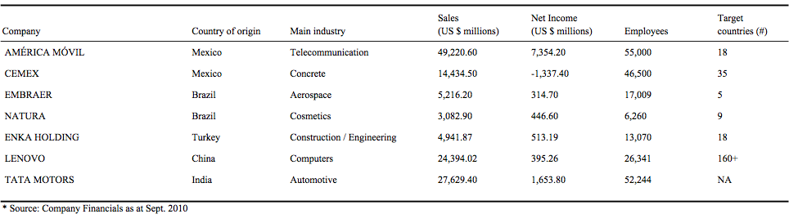

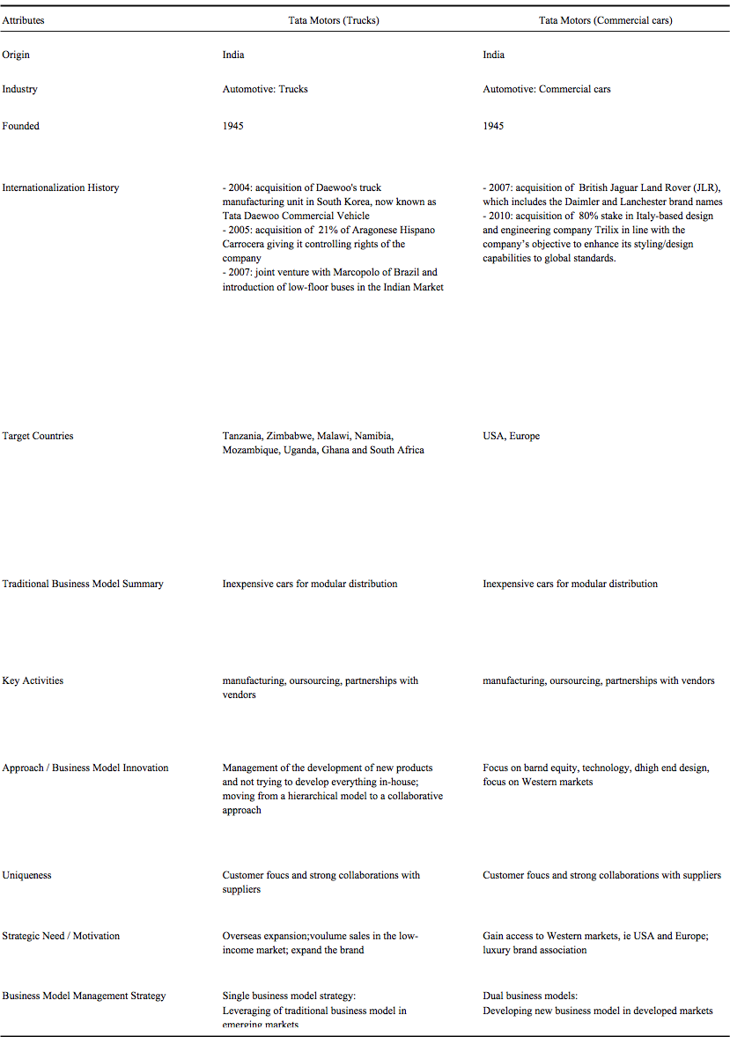
Table 2: Summary of Case Studies Analyzed

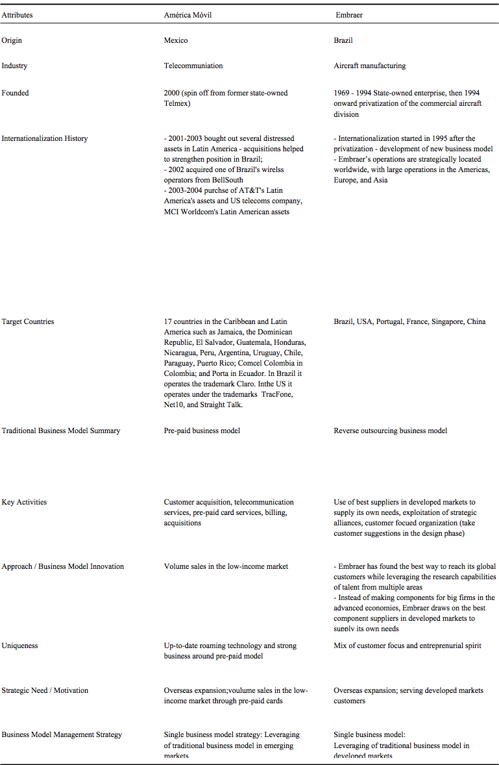
Table 2: Summary of Case Studies Analyzed (continued)
Table 2: Summary of Case Studies Analyzed (continued)
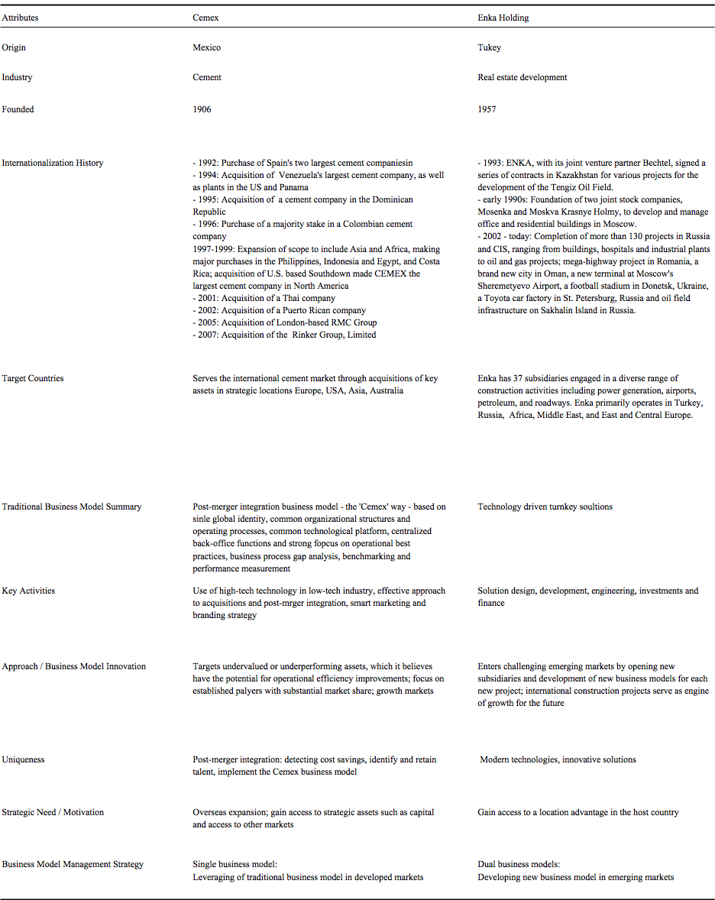

Table 2: Summary of Case Studies Analyzed (continued)

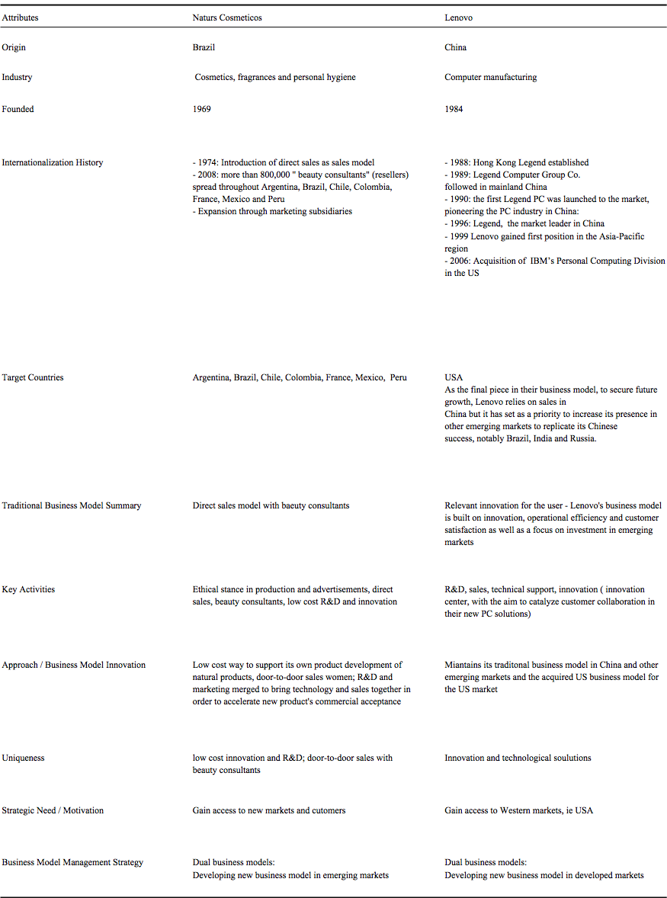

Figure 1: Business Model Management Strategies of Emerging Markets Multinationals
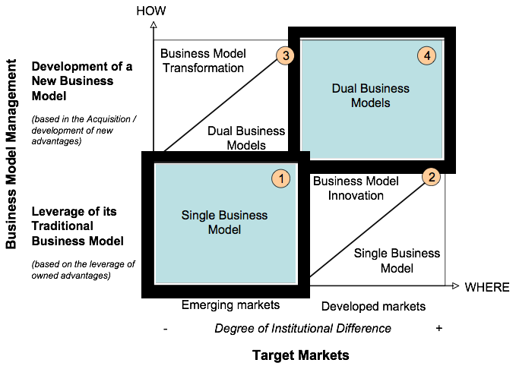

Figure 2: Business Model Management Strategies: Case Study Illustrations
